# Before You Begin

Before you start using the **Health Data System (HDS)\***, we recommend that you become familiar with a few fundamental uses of the system. For information not covered in the User Guide, refer questions to your local system administrator or manager.

Be sure you know…

* Who to contact for questions and access issues
* The link that opens the login page.
* How long the application can be idle before an active session ends (log in again)
* How to log out
* How to update your profile
* How to personalize your dashboard

**\*** The Health Data System was formerly called BACTESCloud. The BACTESCloud logo currently appears on the system screens.

Topics in this chapter

**A tour of Health Data System**

Describes use of HDS to process requests.

**Logging In**

Entry screen and steps for login.

**Logging Out**

Steps for closing HDS.

**HDS Session Timeout**

Notification that the system has been inactive for a time period longer than allowed.

## A Look at the Health Data System Request Process

Health Data System automates request processing…a built-in workflow moves requests through a sequence of *queues*. The status of the requests determines when and to which queue it moves. Employees receive online notification when requests are assigned and a direct link to each request.

The requester also receives notification as the request moves through the process.

The HDS automated end-to-end process is run by a workflow defined by HDS business operations. The diagram below illustrates the *life of a request.*

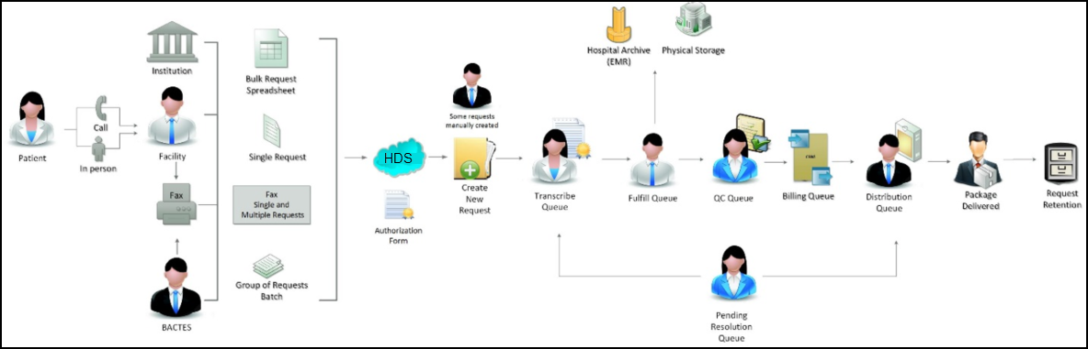

**Here’s how it works.**

A request begins….

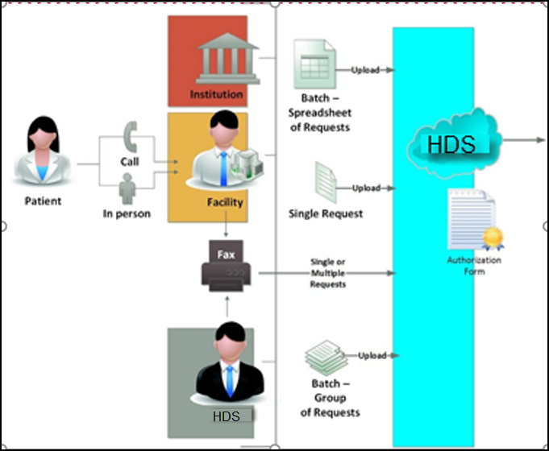

1**. Create Request**

Requests will come in from HDS requesters that can be clients, patients or HDS employees. Now, you (as client or employee) can quickly start the process right from your desktop.

HDS prompts you to select one or more files from your existing folders. After checking that the list of files is complete, you will *upload* the files (move the files) into HDS to

* Create a single request, or
* Create multiple requests (from a group of separate documents), or
* Create multiple requests (from a spreadsheet)

You also will *upload* when adding documents to existing requests.

During the upload step, you can re-assign the Document Type for any selected file, or remove a selected file before creating a request.

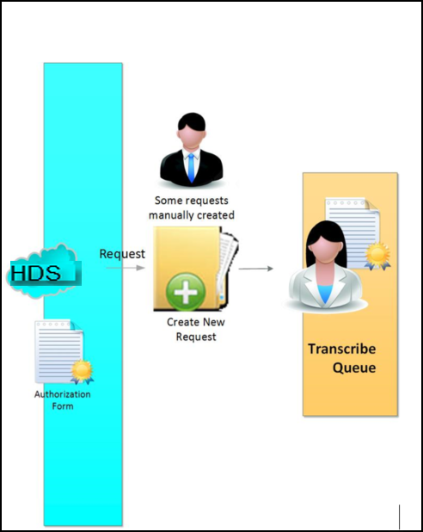

2**. Transcribe Queue**

Newly created requests automatically move to the Transcribe Queue, where authorized employees key in all needed information – the patient, the client, the requester, etc.

If information is accessible from the system, such as client and requester information in CRM, you can automatically add it to the request without manually typing it in.

When the transcribe task is complete, the request moves to the Fulfill Queue.

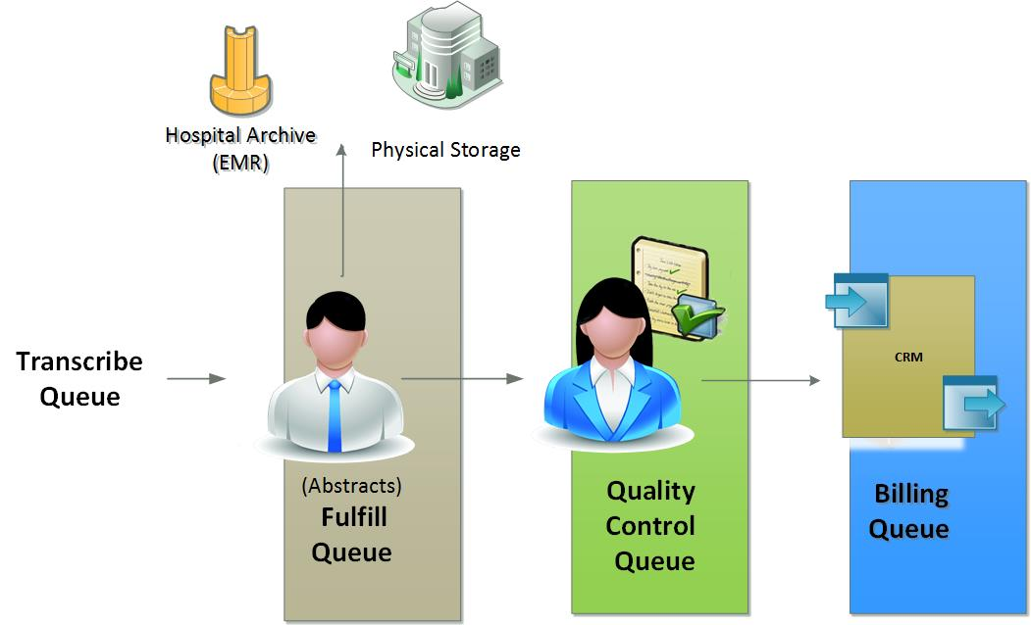

3. **Fulfill Queue**

From the Fulfill Queue, authorized employees collect the patient records required for the request (Abstracts). After scanning or downloading, these documents are uploaded to HDS. When fulfilled, the request moves to the QC Queue.

4. **Quality Control Queue**

Here the request is checked online for quality, such as for correct abstracts and the correct recipient. Once the request is complete and quality-checked, it moves to Billing.

5**. Billing Queue**

The system workflow places the request on hold and checks the billing status against the CRM. If the CRM confirms status and returns an OK to release, the request moves to the next step.

6. **Distribution Queue**

Standard options:

* Print and mail
* Create a CD and mail
* Send to an FTP site for pick up

Electronic (eDelivery) options:

* OnDemand
* Upload to customer
* Secure email
* Patient Pay Portal

Package delivery follows the specification in the request: “Ship-to” or “Receiver.”

**Pending Resolution Queue**

Requests move to the ***Pending Resolution Queue*** when they require fixing or when, for other reasons, request processing cannot complete.

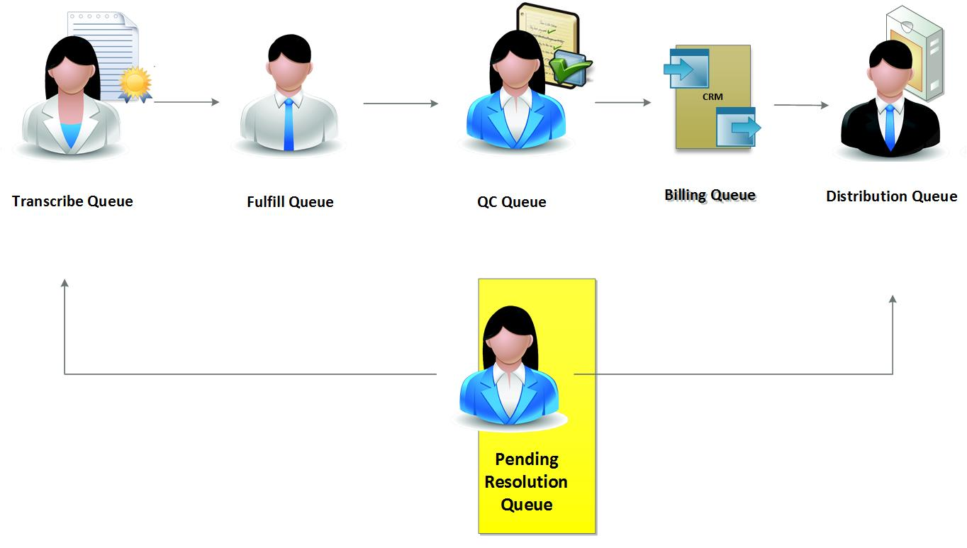

When in the queue, requests can be completed or can be returned to any of the queues for handling.

**Retention/ archive policy**

Requests and abstracts remain in the system for the time designated by business policy.

## Logging In and Out

Follow these instructions for logging in to and out of HDS.

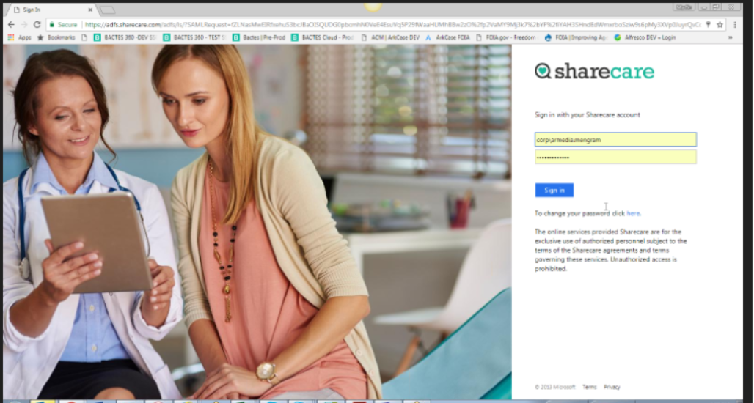

### Logging in

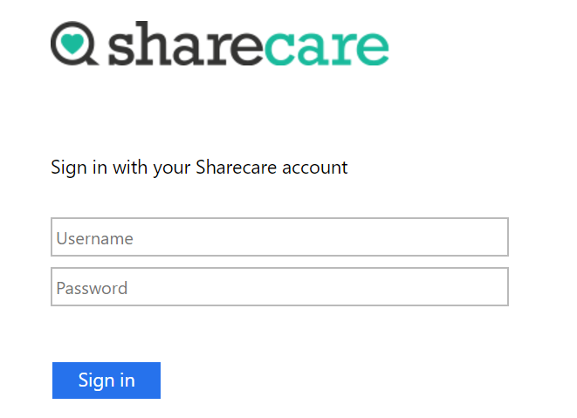

1. Enter your username.
2. Enter your password.
3. Click **Sign In**.

### Logging out

You can log out from anywhere in HDS.

1. Click in the **Profile** frame at the top left in the sidebar. The **Profile** menu opens.

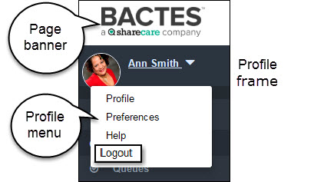

1. Click **Logout** to close HDS.

You will be returned to the *Login* screen.

## HDS Session Timeout

After a designated time of system inactivity (for example, 20 minutes), your online session will expire. The application closes and the message below appears on the login page.

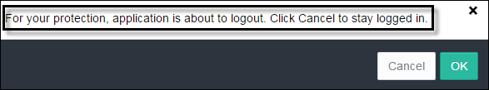

To resume work, click **OK**.

**Important!** Don’t unnecessarily lose work to session timeouts. Make regular saves part of your routine. Click the  **Save** (disk) icon as you work.

# Getting Around the Health Data System

At center of the HDS system is a group of integrated request *queues*, each of which has a purpose in the BACTES core business operation.

* Queues are online containers through which requests automatically move–add new requests, track request processing, and complete requests.
* Search, filter, and sort are tools for quickly finding and grouping requests in the system.
* The Dashboard, which is **your** system landing page, opens first thing every day. It shows a list of all of **your** requests in progress, and a direct link to each.

Topics in this chapter

**The Health Data System Page**

The page layout carries throughout HDS.

**Health Data System Queues**

The list of the request-based modules that comprise HDS.

**Finding Content**

An introduction to the options for searching HDS content.

## The Health Data System Page

HDS makes it easy to find your way around. All pages have a similar look and feel. The topics in this section point out the parts of the page and their use.

The HDS page has three major elements: page banner, sidebar, and content space. The largest element of the page—the content space—displays the content of the selected module.

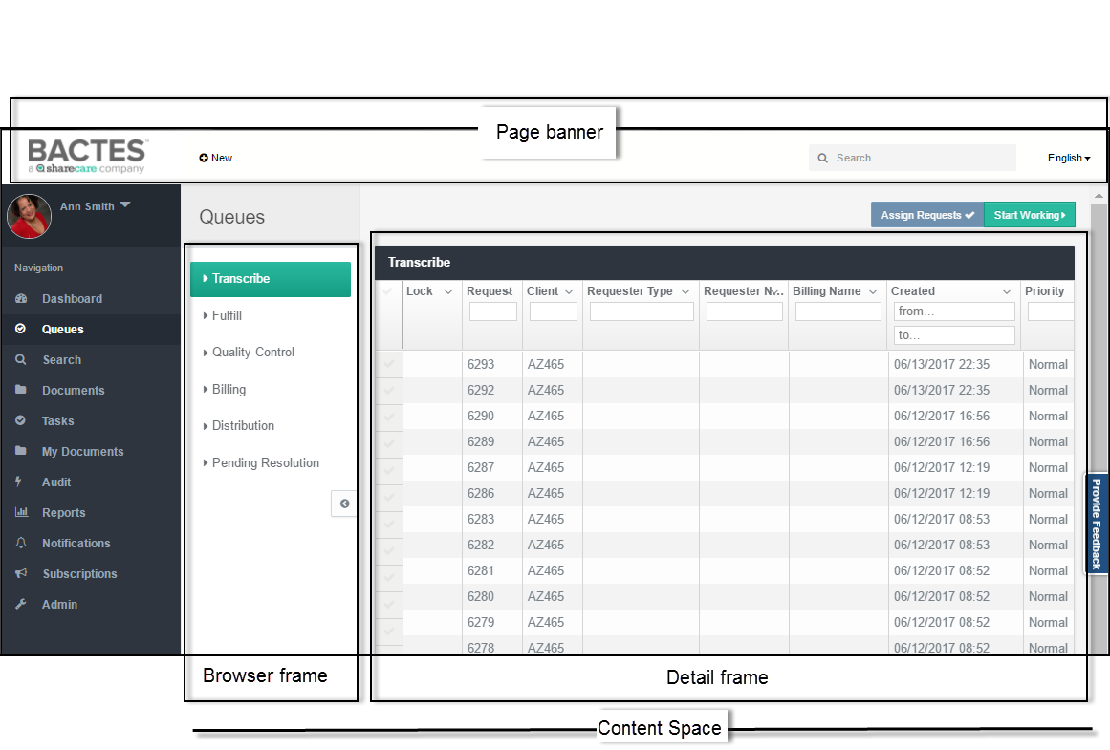

The banner (top) and sidebar (left panel) form the page borders, and appear as standard elements throughout the system.

### HDS Page Banner

The banner is the top border of the page (screen). The sections below describe its elements. These links are available from anywhere you are in HDS.

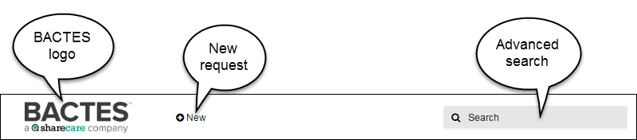

#### Logo

Click the logo from anywhere in HDS to return to your **Dashboard** page.

#### New menu

The **New** button opens a menu.

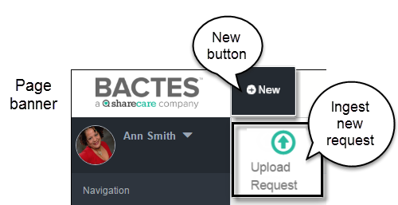

The menu is the initiation point for ingesting (creating) new requests.

#### Search box

Use the text box to perform *global* searching of all request-related information in the system. After typing in the search request and clicking ***Enter***, the **Search** module opens to display the results.



You must have permission to view any search result.

For more information, please go to the ***Search*** section in this guide.

### Page Sidebar

The sidebar, which forms the left border of the page, is available on every HDS page. The sidebar consists of two frames.

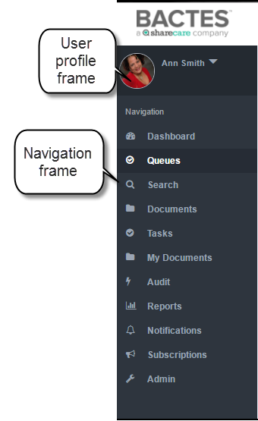

|  |  |
| --- | --- |
| *Sidebar frames* |  |
| **User Profile** | Identifies you as the logged-in user. The frame makes available a menu of user actions. |
| **Navigation** | Shows the list of implemented and future HDS modules. You see only the modules to which you have access. |

#### User Profile Frame

The Profile menu makes available a small set of actions.

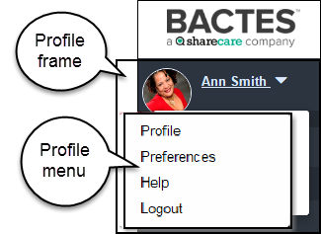

|  |  |
| --- | --- |
| *Profile menu options* |  |
| **Profile** | Opens your profile page. |
| **Preferences** | **---Future Release---**  Sets options for displaying content. |
| **Help** | Links to the Help pages (HDS User Guide). |
| **Logout** | Closes your HDS session. |

For more information, please go to the sections ***Your Profile*** and ***Logging In and Out*** in this guide.

#### Navigation Frame

Each tab opens a module page.

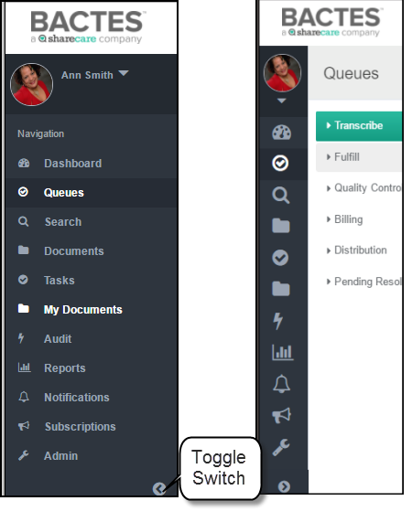

The **Toggle** button (at the bottom of the ***Navigation*** frame) switches between *show* and *hide* the module titles on the list. When the titles are hidden, the content space is widened.





The Navigation frame you see may be different than the example above. The list will show only the modules to which you have permission.

### Content Space

The content space is the display element of the page. Depending on the module, the space displays:

* Widgets in the dashboard
* Request queue content
* Search results
* Documents
* Tasks
* My Documents
* Audit
* Report results (user role-based access)
* Subscription and notification results
* Audit report (user role-based access)
* Administration tools (user role-based access)

Content displays in two frames: the **Browse** frame and the **Detail** frame.

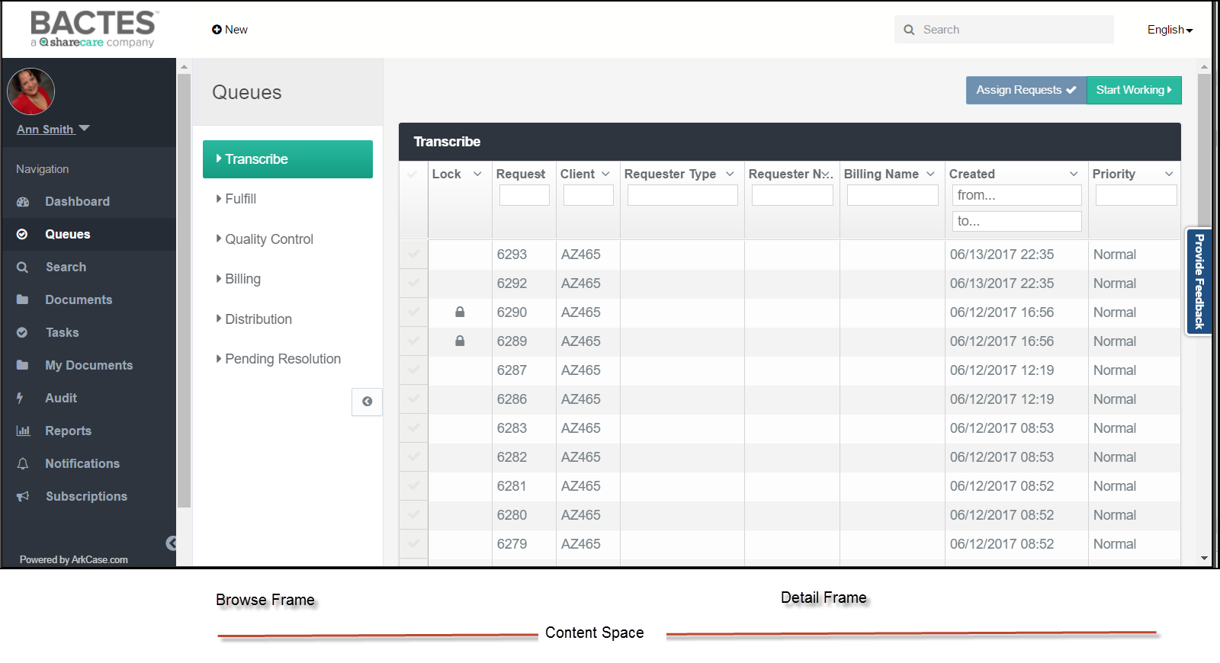

|  |  |
| --- | --- |
| *Content frames* |  |
| **Browse** | Shows lists or parameters. From here, you can locate and organize module content. Only the modules and queues that you have access to will appear on the page. |
| **Detail** | Displays the content of the selected item, for example, content of the selected queue, or the results of searches and reports. |

***Dashboard page***

The **Dashboard** module is the exception to the standard page layout. There is no ***Browse*** frame.

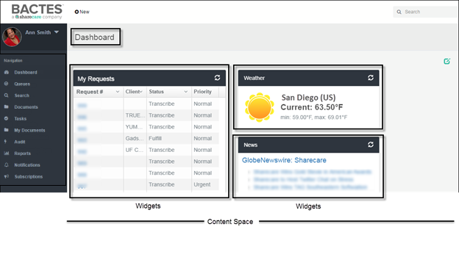

The Dashboard content consists of the widgets you choose to display on the page. For more information about the Dashboard and widgets, please go to the section ***Your Dashboard*** in this guide.

## Health Data System Modules

HDS is a collection of individual, and integrated, modules (and queues) designed for managing the request process.

The ***Navigation*** frame is the list of the HDS modules. Your organization may not use all of them now. Module access is limited by *permissions*–for example, not all employees can view or modify all requests in progress.

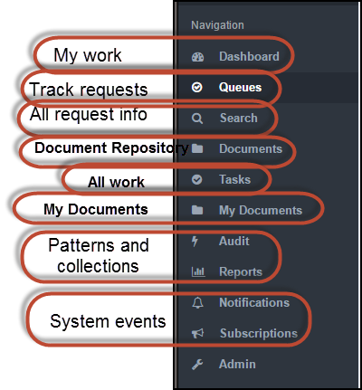

**What they do**

The modules are integrated. Starting with newly created orders, a business workflow moves requests through the completion phases—from transcribe to distribution.

|  |  |
| --- | --- |
| ***Process requests*** | Online action—initiate, fulfill, quality control, billing, distribution, and resolution—automatically updates status and triggers the pre-defined business process that places the request in the (next) appropriate queue. |
| ***Trends and behavior*** | Search and audit read all data stored in the system. Stored data covers request information as well as system actions taken during request completion. The requester can see only the results for which permission exists. |

|  |  |  |
| --- | --- | --- |
| ***HDS modules*** |  |  |
| *My requests in progress* | **Dashboard** | Your HDS landing page. Here you see the list of requests belonging to you. |
| *Track requests* | **Queues** | *Containers* store requests by status. HDS moves requests between queues as status changes. Queues make available online tools for initiating, updating, tracking, and closing. |
| *Find information* | **Search** | You define the set of data you want to see by entering full or partial content information. The *global* search scans the entire repository (historical and in-progress requests): documents/files, request numbers, client and requester names and codes, assignee names, patient names, and full address information. |
| *Store documents* | **Documents** | A location for storing documents in HDS |
| *My work* | **Tasks** | A list of actions assigned to me or my group |
| *Store your Documents* | **My Documents** | A location for storing your documents in HDS |
| *Summarize information* | **Reports Audit** | Authorized users can create parameters for selecting and running reports of request turnaround time and of request-related *actions*. |
| *“Follow” requests* | **Notifications Subscriptions** | **--Future Release--** Collection of user-specific event logs created by the *system*. |
| *Maintenance and configuration* | **Admin** | Restricted to technical and super users. From here, authorized employees can manage behind-the-scenes operations such as application-level security and access control; configuration (of reports, workflow, modules, fields); and request locking. |

# 

# Your Profile

Your HDS user profile is the space for identifying yourself–by role(s), contact information, location information...even by profile picture.

Here you can see at a glance the organizational groups to which you belong, your title, and your work location. Profile details are particularly helpful when team members work in different locations or for different organizations.

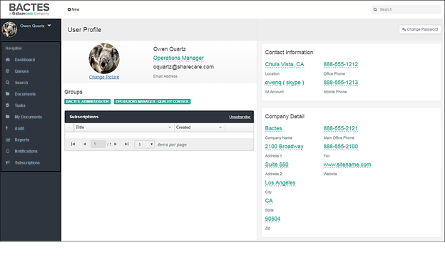

You can view and update your profile from anywhere in HDS.

Topics in this chapter

**Opening your Profile**

Quickly locate and view your profile.

**Updating your Profile**

Create and update your profile page.

## Opening Your Profile

Only you can open and view your profile–at any time, from anywhere in HDS.

Follow these steps for opening.

1. Click the ***User Profile*** frame to open the menu.

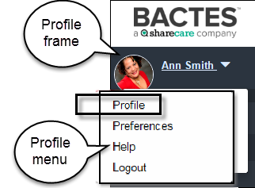

1. Click the **Profile** option from the list.

The first time you open your ***Profile*** page, the page will look similar to the example below.

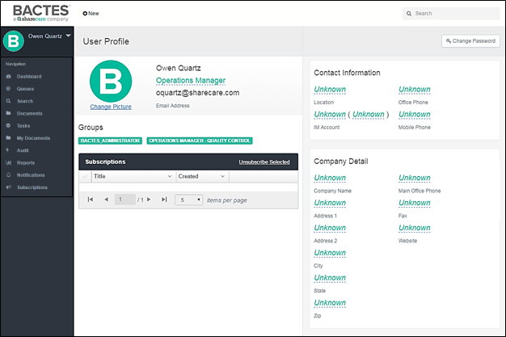



The Profile pre-fills your name and e-mail address. You will add the missing (Unknown) information.

## Updating Your Profile

You can return to your profile page at any time to update professional details as changes occur. For example, you can change your title or role, your contact information, and your picture.

1. Click the **Profile frame** to open the pop-up menu.

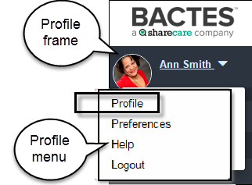

1. Select **Profile** from the list of options. Your Profile page opens.

#### Profile Content

You have access to most fields on the Profile page.

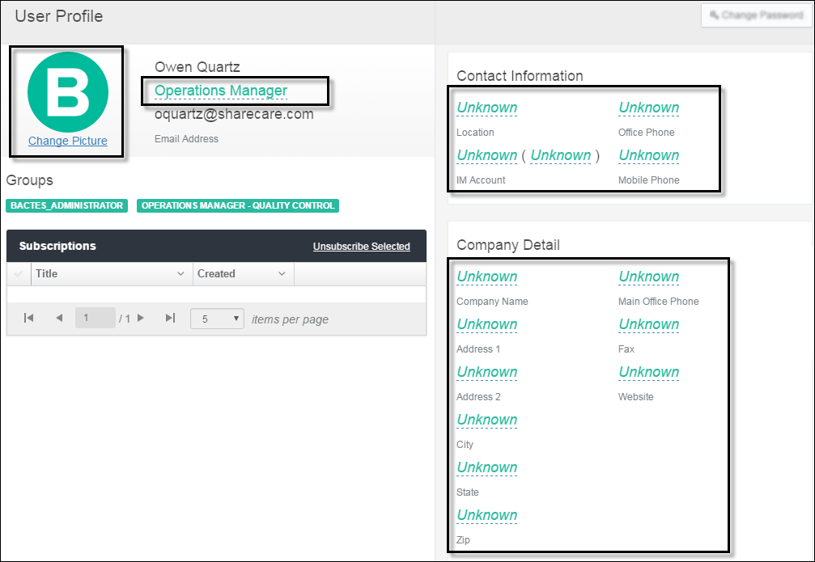

Navigate the page to add and update your profile. All fields on the Profile page are hypertext links marked by ***dashed underline***.

1. Click the ***Unknown*** hypertext to open a pop-up text box. The first time you open the link the box will be empty.

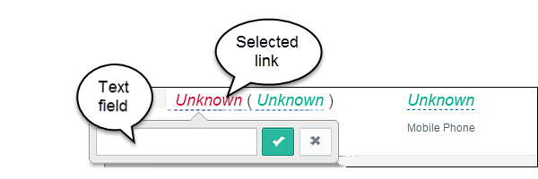

All of the underlined fields can be updated. The pre-filled ***Unknown*** indicates no existing information.

1. Type in the detail that you want to appear in the fields of your profile.

To change an existing entry, click the link to open the text box.

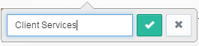

Remove/replace the existing text.

1. To save your entry, click the  **Save** (check mark) button. The new detail appears in your profile.
2. To close the text box without saving, click the  **Close** (X box) button.



You can change profile details at any time by clicking the current content and updating the information in the pop-up box.

1. Continue through every field that you want to add or change.

#### Your Picture

Follow these steps to add or change your picture.

1. Click the Change Picture link. Windows Explorer opens your shared drives and folders.
2. Locate and select the image you want to upload.
3. When the file name appears in the ***File name*** field, click **Open**. The image is added to your profile.



Acceptable image file formats are .**jpeg/jpg**, .**png**, and .**gif**.

#### Groups

The user/security group(s) to which you belong appears in the ***Groups*** section of the page. System Administration creates and maintains permissions.

#### Change Password

Not Applicable. There are no separate credentials required for HDS login.

#### Close the Profile Page

When the information is complete, click one of the modules in the ***Navigation*** frame or log out of HDS.

# 

# Your Dashboard

The **Dashboard** is *your* HDS landing page—it's the first page that opens when you log in. The Dashboard shows your work status in one place. Status information is consolidated in *widgets*.

Widgets show you a list of items in progress—active requests assigned to you. The widgets also give you quick access to each individual request. From the ***My Requests*** widget, you can click a link to open the item.

Because it’s *your* page, you can configure the Dashboard however you like—you're the only person that sees it.

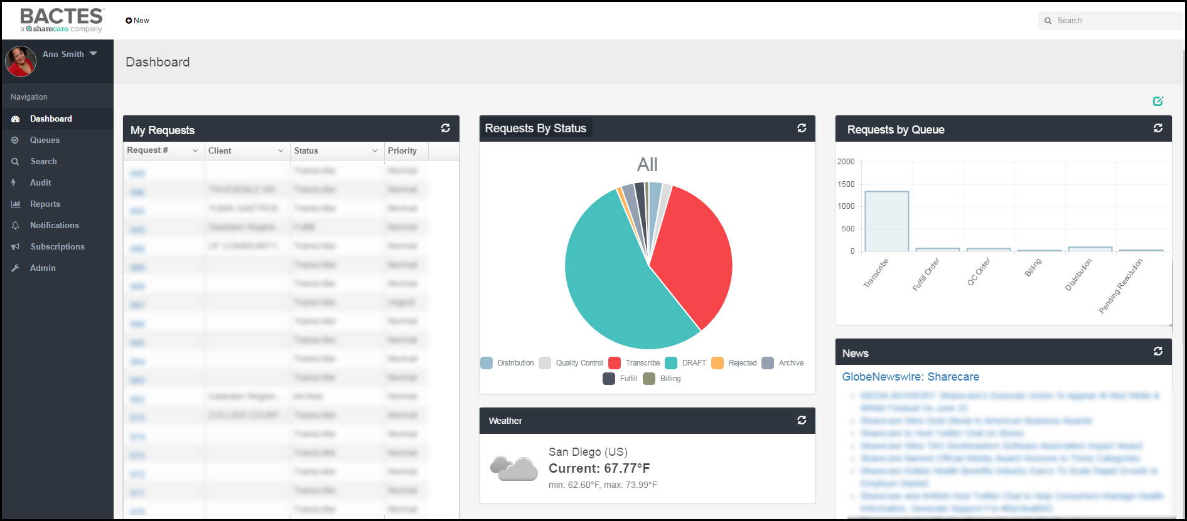



Your role(s) and permissions determine the widgets and the content that you see.

Topics in this chapter

**Dashboard Edit Mode**

First step in customizing your Dashboard.

**Personalizing the Widgets**

Working with the elements of the Dashboard.

**Personalizing the Space**

A tour of the Dashboard page layout options.

## Dashboard Edit Mode

Actions to the page require that the Dashboard be in *edit mode*. Edit Mode makes available the options for editing components of the page. By default, the Dashboard is *not* in edit mode. Switch to *edit* to begin. Edit Mode enables the options to:

* Add widgets to your dashboard (permissions determine the widgets available)
* Modify widget display (change content, move position, remove from view)
* Configure the layout of your dashboard (names of widgets and the number displayed in each row)

The first step to personalizing your Dashboard is *edit*. To make available editing options, click the  **Edit Mode** (pencil icon) button in the right corner of the Dashboard title bar.

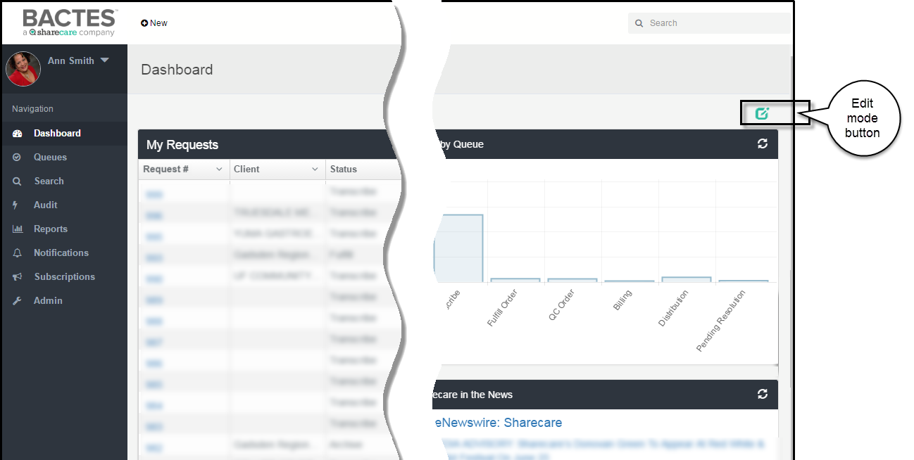

### Dashboard Edit Actions

When edit mode is enabled, a set of edit buttons becomes available in the Dashboard title bar.

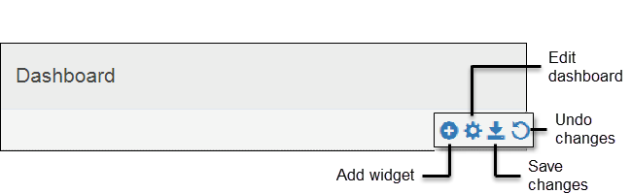

|  |  |
| --- | --- |
| *Dashboard edit mode buttons* |  |
| **Add Widget** | Opens the list of widgets, you select the ones that you want to see on your dashboard. |
| **Edit Dashboard** | Opens the options for reconfiguring the widget display on the dashboard. |
| **Save Changes** | Saves the changes made to the dashboard, closes Edit mode. |
| **Undo Changes** | Restores original settings, closes Edit mode. |

### Widget Configuration Buttons

After enabling the Dashboard edit mode, widget configuration buttons automatically appear in the widget title bar.

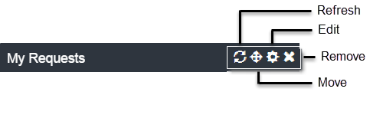

|  |  |
| --- | --- |
| *Widget configuration buttons* |  |
| **Refresh** | Updates (reloads) content with the latest available information: updated requests; latest request status; news and weather. |
| **Move** | Permits dragging of the widget to a new location on the dashboard. |
| **Edit** | Opens a text box for changing the title of the widget; the time for collecting data; and the outside source of non-business content. |
| **Remove** | Hides the widget from display on the dashboard. |

## Personalizing Dashboard Widgets

The widgets on the dashboard give you a simple and up-to-date overview of work in progress. You can directly open a request from the list in the widget. After adding widgets to the dashboard, you can configure and move them around in the space.

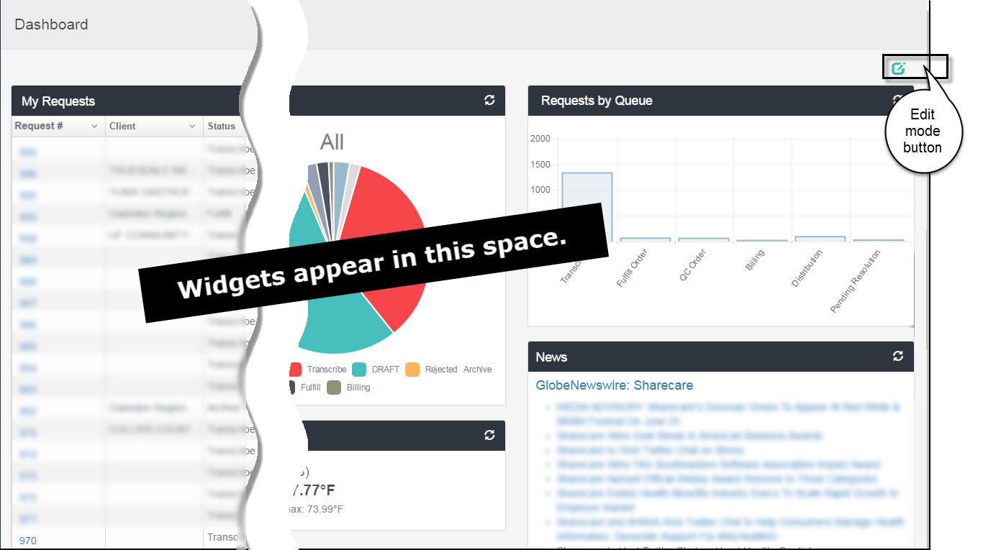

### Widget Actions

Add a Widget to Your Dashboard

Edit Widget Configuration

Move a Widget

Remove a Widget

#### Add a Widget to Your Dashboard

* Widgets showing status
* Widgets showing summary data
* Widgets showing external data
* Widget showing the HDS archive

You choose the widgets that you want to see.

1. If the Dashboard page is not in edit mode, click the  **Edit Mode** (pencil icon) button on the Dashboard title bar.

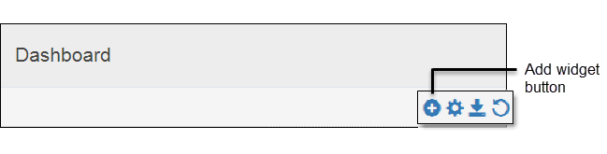

1. In Dashboard edit mode, click the  **Add** (plus sign) button on the Dashboard title bar to open the **Add New Widget** menu.

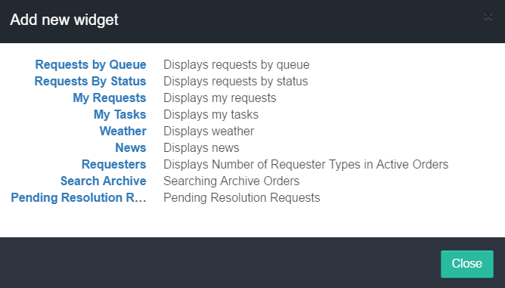

1. Click a widget title to select it.

The **Add New Widget** dialog box will close and the widget will be added to your dashboard.



Names of widgets and number of available widgets may be different than the example.

##### Widgets showing status

The **My Requests** widget is a list of those items to which you are assigned and for which the status is incomplete.

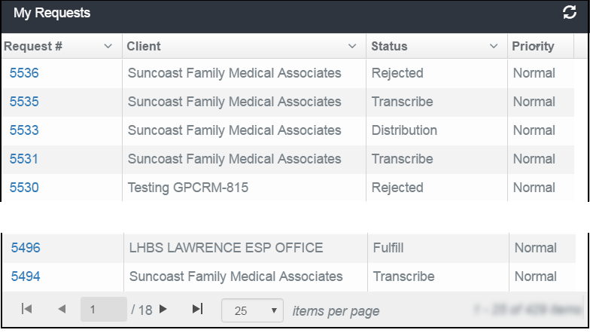

The widget identifies each item by metadata (information) such as number, client, priority, date, and status.

Each item in the **Request Number** column is a hyper-link, from which you can open the selected request.



The Admin role has permissions to see all existing orders in all queues. Depending on your role, the widget will list only the current orders and the queue assigned to you.

##### Widgets showing summary data

Widgets such as ***Requests by Status***, ***Requests by Queue and Requesters*** display cumulative content as a pie chart or graph. See the pie chart example below.

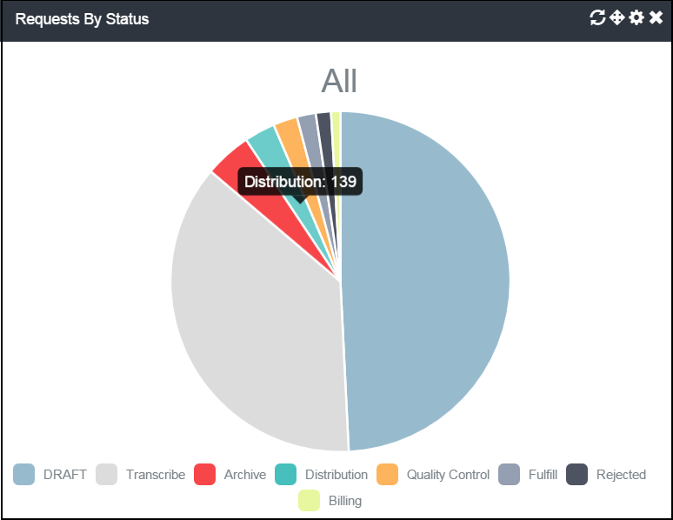

To see the numeric value that a section of the pie chart represents, move your cursor over the chart. A hover box will show the number.

* To **specify a period** for data collection, click the  **Configuration** (cog) icon (requires Dashboard *edit mode*).
* To **refresh the results** with latest information, click the  **Reload** icon.

##### Widgets showing external data

These widgets show information that originates from external sources. Widgets such as **Weather** and **News** are independent of the HDS repository.

##### Widget showing the HDS archive

The Archived Requests widget is the list of all requests that have been moved to archive.

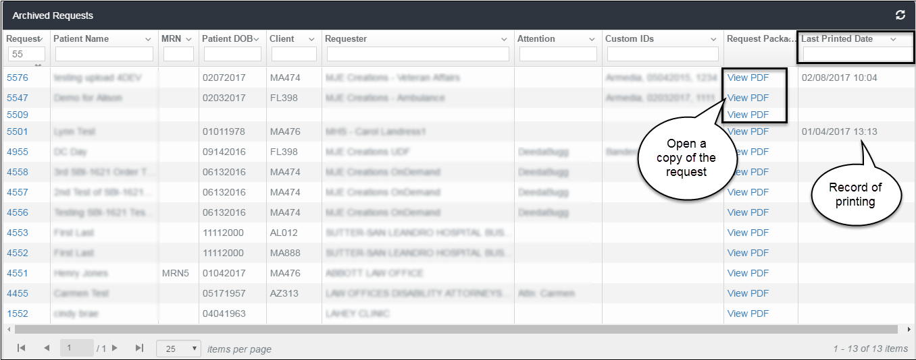

You can filter and sort the list columns as you would any other widget. You can see the content of the request by clicking the **View PDF** link in the ***Request Package*** column. HDS also stores and displays **Last Printed Date**, which you can use in search and audit criteria.

### Edit Widget Configuration

You can modify basic elements of the widget display–change its title or the number of items that display on a page. Options available depend on the widget content and access permissions.

1. If the dashboard page is not in edit mode, click the  **Edit Mode** button on the Dashboard title bar. The control buttons become available on the widget title bar.
2. Click the  **Edit Widget Configuration** button on the widget title bar.

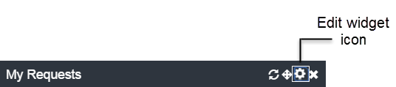

The edit widget dialog box opens.

#### My Requests widget

#### Requests by Queue widget

You can change the name that appears on the title bar of the widget.

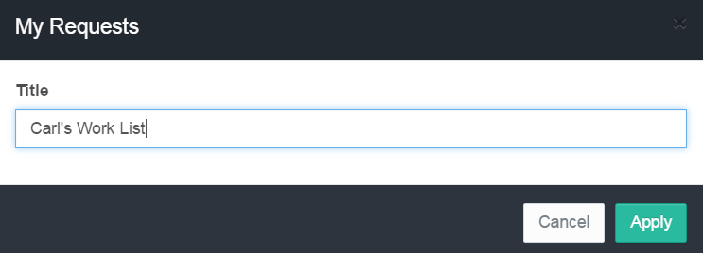

1. Click in the **Title** text field and edit the current content.
2. Click **Apply** to save the change and close the dialog box.

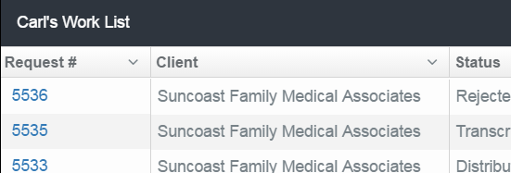

#### Requests by Status widget

You can change the title of the widget and the default time period for which to collect data.

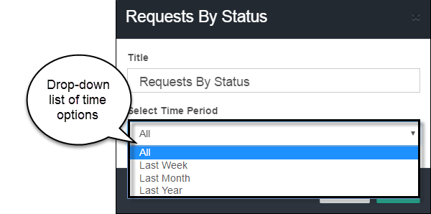

1. Click in the **Title** text field and edit the current content.
2. Open the drop-down list in the **Select** Time Periodfield. The default setting is ***All***, that is, no time limit. Options for narrowing the comparison are previous ***Week***, ***Month***, and ***Year***.
3. Click **Apply** to save the change and close the dialog box.

#### Externally linked widgets

Two widgets provide Weather and News information.

Both configurations allow changes to the widget title, in the same manner as all the other HDS widgets. To activate widget content:

|  |  |
| --- | --- |
| *Widget* |  |
| **Weather** | To see basic weather information, enter a city, state, and country abbreviation (U.S.). |
| **News Feed** | Enter the URL of the news source. |

### Move a Widget

You can move a widget from one location on the Dashboard to another.

1. If the dashboard page is not in edit mode, click the  **Edit Mode** (pencil icon) button on the Dashboard title bar. The control buttons become available on the widget title bar.

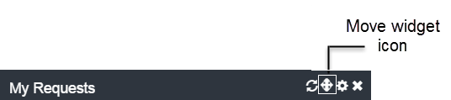

1. Click and hold the  **Change Widget Location** (cross) icon and drag the widget to the new spot in the Dashboard content frame.

### Remove a Widget

You can remove a widget from *your* dashboard. The action hides the widget from view, it does not delete the widget from the system.

1. If the dashboard page is not in edit mode, click the  **Edit Mode** button on the Dashboard title bar. The control buttons become available on the widget title bar.

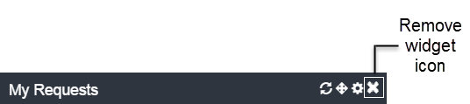

1. Click the  **Remove Widget** (X) icon to hide the widget from display. The widget will not appear again until you add it.

### Widget Content

You have several options for viewing widget content.

* Sort the List
* Hide Content
* Adjust Column Width
* Change List Scrolling Options
* Navigate the List Pages
* Refresh Widget Content
* Link to Requests

#### Sort the List of Requests

Arrange and locate content using Sort. Sort is available in each data column of the ***My Requests*** widget.

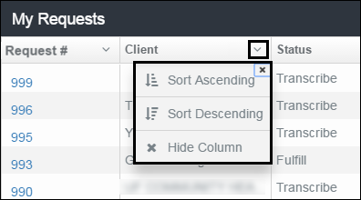

1. To re-order the list, click the  **Disclosure** (down arrow) button in the column heading to open the selection box.
2. Select the request—ascending or descending—for re-displaying the list content.

#### Hide a List Column

1. Click the  **Disclosure** (down arrow) button in the column heading to open the selection box.
2. To show the list *without* the column, click **Hide Column**.
3. To restore the column to view, click the widget  **Reload** icon.

#### Adjust column width

You can widen (or narrow) the size of any column in the results list.

1. In the header row at the top of the list, place the cursor on the column border. The cursor will change to a double line.

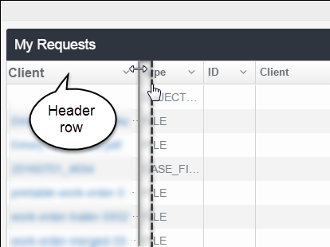

1. Drag the line to the right or left to adjust the width.

#### Change the List Size Display

The default number of items showing on each page of the Requests widget list is 25. To view item 26, you must navigate to the next page.

1. To increase (or decrease) the number of requests you want to see on each screen (page), scroll to the bottom of the widget list.

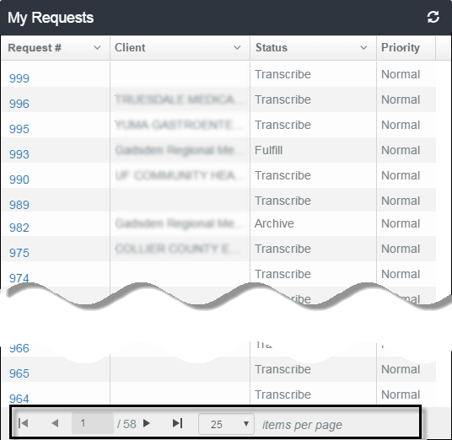

1. Next to the *items per page* label, click the  **Disclosure** (down arrow) button in the column heading to open the selection list.

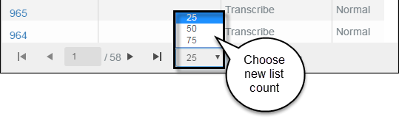

The default display setting for the Requests list is 25 items per page. You can change the count to 50 or 75.

1. Click to select a new count. The selection dropdown closes and the list length adjusts to the new size.



You can change the list item size at any time. It is not necessary to enable the dashboard edit mode.

#### Navigate the List Pages

To move between pages in the widget, use to ***GoTo***arrows at the bottom of the list.

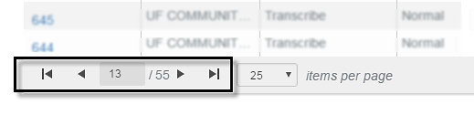

1. Page forward: Click ▶ to open the next page, or ▶**|** to go to the last page of the list.
2. Page backwards: Click **◀** to open the previous page, or **|◀**  or to return to the first page of the list.

#### Refresh Widget Content

Use the Reload (refresh) action to update content with the latest information.



Click the  **Reload** button. The widget content will automatically refresh the latest information.



You can reload widget content at any time. It is not necessary to enable the dashboard edit mode.

#### Link to Your Requests

Each Request number on the widget list is a hyperlink.

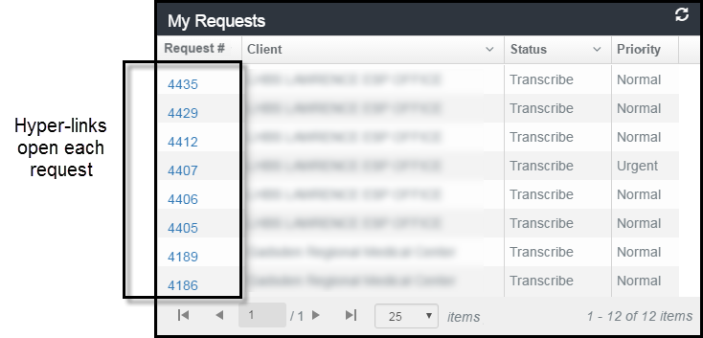

Click the link to open a request. Only the request number in the **My Requests** widget is an active link.

## Personalizing the Dashboard Page

You can personalize your dashboard page by changing the title of the page and by changing the display structure of the content frame.

The Dashboard page has three major components: the title bar, the Edit mode button, and the content space which displays the widgets you choose to see.

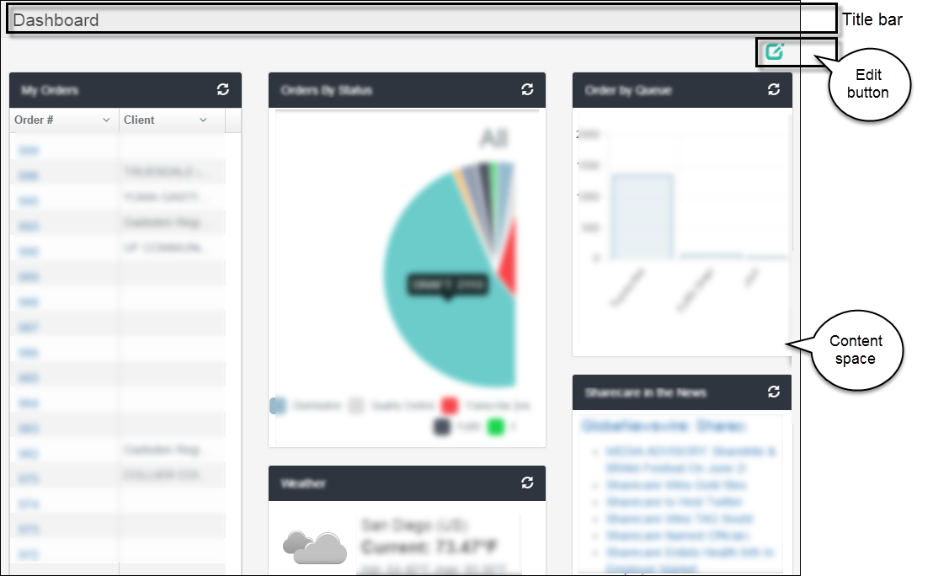

### Change the Title of the Dashboard Page

The default title of the page is "Dashboard." You can personalize it to read whatever you want, for example, "Bill's Dashboard."

1. If the dashboard page is not in edit mode, click the  **Edit Mode** button on the Dashboard title bar.

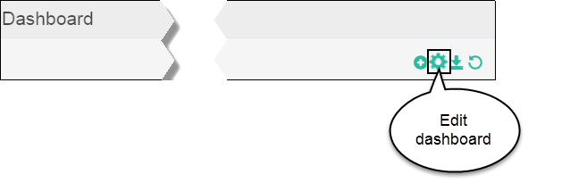

1. Click the  **Edit Dashboard** (cog) button on the Dashboard title bar. The ***Edit Dashboard*** modal window opens.

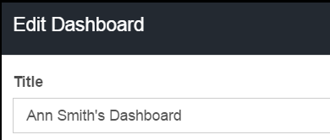



1. Click in the **Title** text field and edit the current content.
2. Click **Close** to save the change and close the modal window.

### Change the Dashboard Page Layout

You can change the structure of the dashboard display—how the widgets line up in the content space.

The layout example below shows the widgets arranged in three columns.

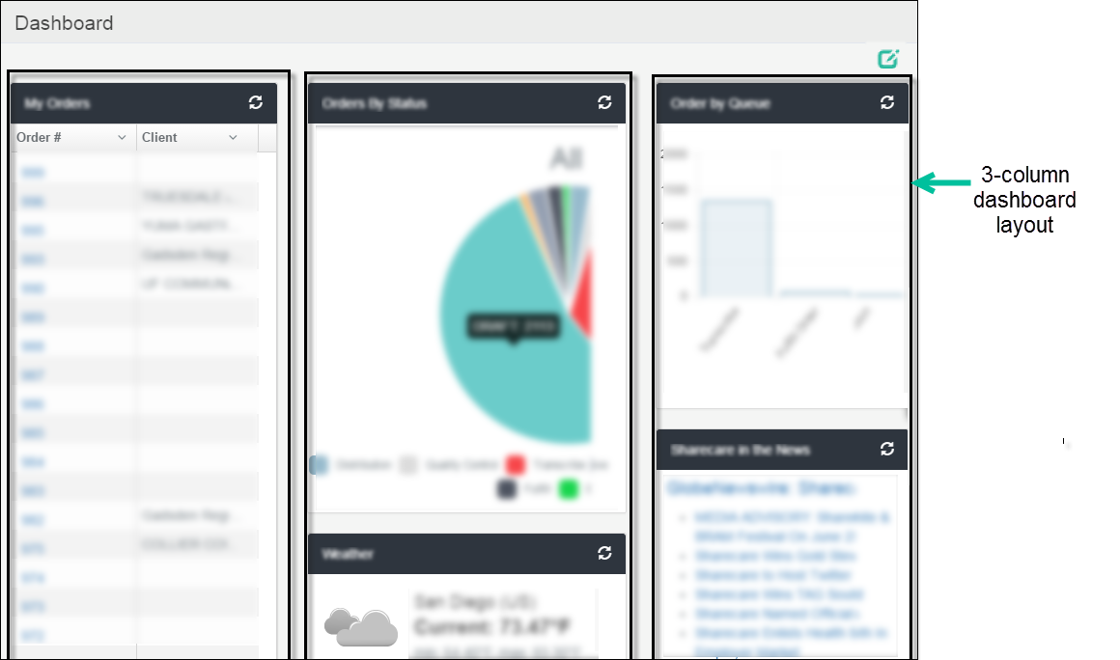

The column widths are adjustable, which affect the presentation of the widget content. There are several options available for rearranging the widgets in the content frame.

1. If the dashboard page is not in edit mode, click the  **Edit Mode** button on the Dashboard title bar.

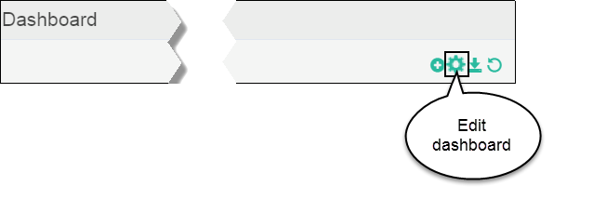

1. Click the  **Edit Dashboard** (cog) button on the Dashboard title bar. The ***Edit Dashboard*** modal window opens.

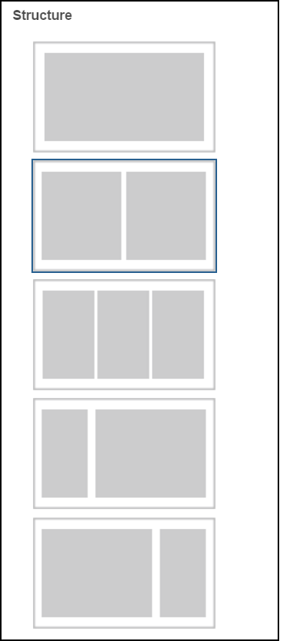

1. Click to select the structure, or layout, in which to see the widgets in your dashboard.
2. Click the **Close** button.
3. To save the new widget arrangement, click the  **Save** icon.

# Create Requests by Upload

HDS streamlines the Create Request process. You can create a new request simply by uploading files online from your computer—a single file, a group of documents, a spreadsheet of requests—to HDS.

The screen below is an example of the **Upload Requests** page.

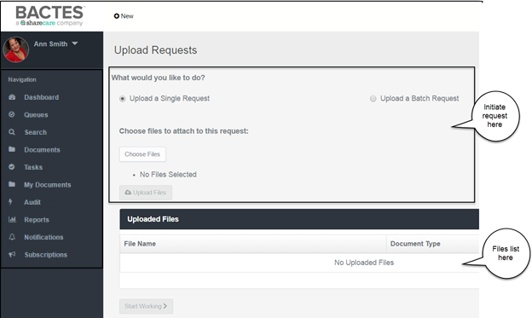

Topics in this chapter

**Upload Single Request**

When selected, you have the option to create a request containing one or more files.

**Upload a Batch Request of multiple documents**

You can upload two or more individual requests.

**Upload a Batch Request from a spreadsheet**

HDS will create any number of requests from a spreadsheet.

## Single Request

This section describes the steps for uploading a *single* request.

***Quick Steps***

|  |  |
| --- | --- |
| 1. **Choose file(s)** | Click *Choose Files* to select files from your shared drives and folders. |
| 1. **Upload the file(s)** | Click *Upload Files* to review the selected files in the ***Uploaded Files*** list. |
| 1. **Change Document Type(s)** | If necessary, change the document type(s) in the request. |
| 1. **“Start Working”** | Click *Start Working* to review and update the request. |
| 1. **Change Client Information** | If the default client needs changing, search for the name to complete the section. |
| 1. **Add Patient Information** | If New Patient, add the required information to the request. |
| 1. **“Create Request”** | Click the button to create the request number and automatically place the request in the ***Transcribe*** queue. |

### Upload a request

Start the request from the **New** menu on the page banner.

1. Click the **+** **New** icon to open the pop-up menu.

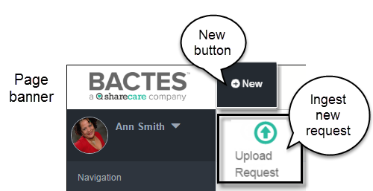

1. Click the **Upload Request** icon to open the request page.

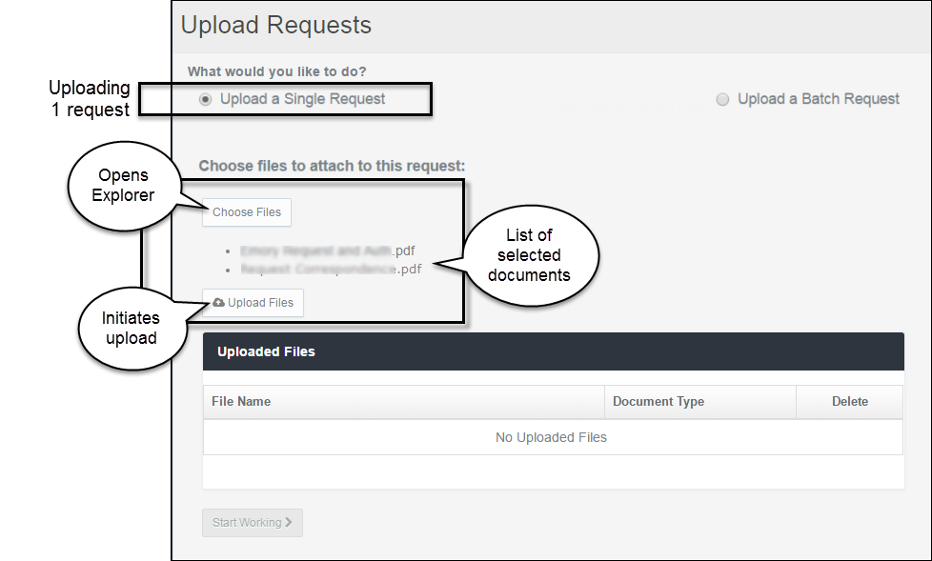

A single request can contain several documents.

|  |  |
| --- | --- |
| *Single Request buttons* |  |
| **Upload a Single Request** | In the section of the page titled *What would you like to* do*?,* select**Upload a Single Request*.*** |
| **Choose Files** | Click **Choose Files** to open Windows Explorer on your computer. |
|  | From a folder, select the file(s) for upload and click **Open**. |
|  |  |
|  | **File Types**  All documents in the request package must be ***.pdf*** files. You can upload other file types (such as Microsoft Office or graphics) and HDS will convert them to *.pdf*. |
|  |  |
|  | The Explorer window closes and the name of the selected file(s) appears in a bulleted list below the *Choose Files* button. |

To delete the entire selection of files before upload, click the ***Choose Files*** button. The Windows Explorer screen opens and the previously selected items are removed. You can reselect files or Cancel to discontinue the request.

|  |  |
| --- | --- |
| **Upload Files** | Click the button to move the file to the ***Uploaded Files*** list. |

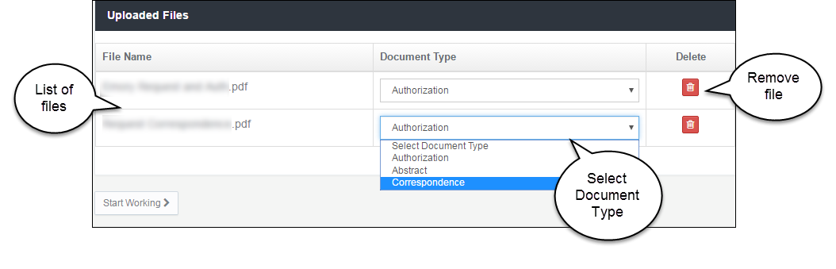

In the example, the request contains an Authorization document and a piece of correspondence. The ***Document Type*** default is ***Authorization***.

* To change the ***Document Type***, open the drop-down list and select another type.
* To remove a file from the request, click the red  **Delete** (trash can) icon.

1. When the documents are complete, click the  button. The ***Single Request*** page opens.

### Create the Request

The screen below shows the first page of the first document in the request, thumbnails of all pages in the document, and the detail tabs for completing request information. By default, the **Details** tab is open.

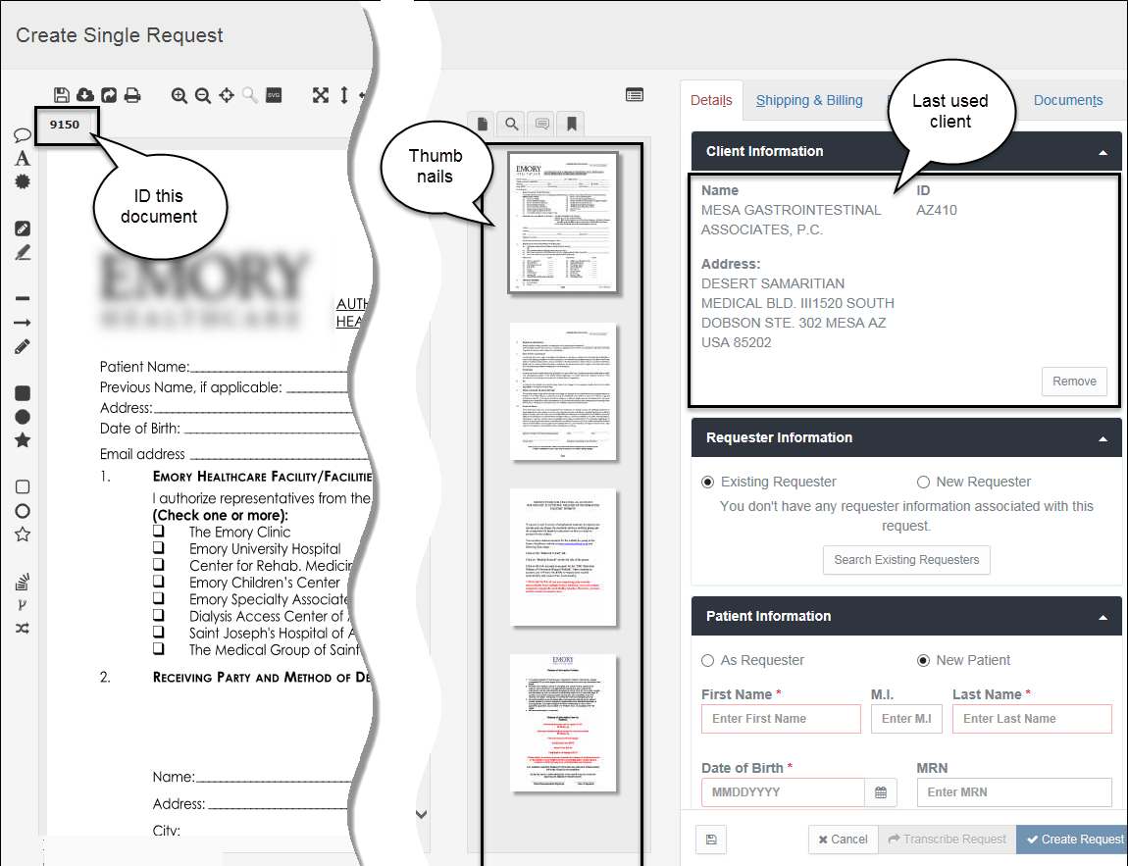

|  |  |  |  |
| --- | --- | --- | --- |
| *Single Request page* | | | |
| **Document identifier** | | The system assigns a unique identifier to each document uploaded. The document number appears in a tab above the document display section of the Request page. The example represents a request containing one document. | |
| **Thumbnails frame** | | All pages of the selected document appear in the narrow thumbnails frame in the center of the page. Click a thumbnail to move through the document and to view the page in the document display space. A toggle above the thumbnails hides the frame from view. | |
| **Document details** | | The ***Details*** tab of the Details frame automatically opens in the Request page. The tab contains information required to create a request. | |
| **Required Details** | When creating a single request, two pieces of information are required: ***Client*** and ***Patient***. | |

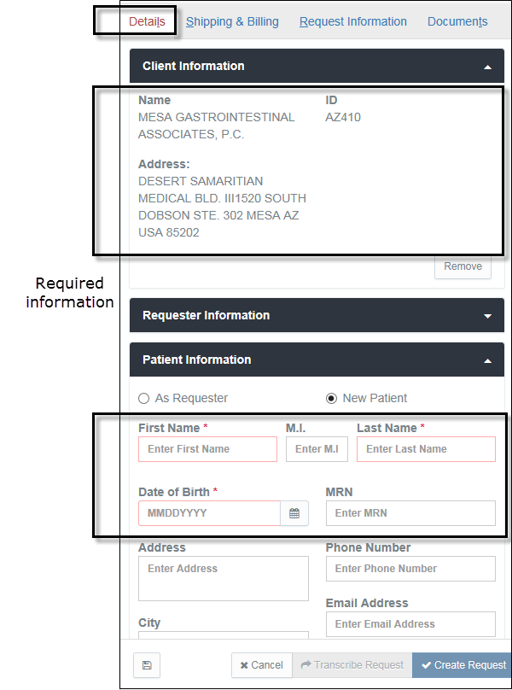

The **Create Request** button is dimmed (not available) until you add the required information. Sections and fields marked with **red** indicate the ***minimum*** information required to create a request.

#### Do you want to change the Client?

When creating a new request, the system pre-fills the ***Client Information*** section with the name of the last client you associated with a request.

The system makes available two sources of client information if a change is needed: a list of recently used clients and search of all clients that you have permissions to use.

1. Click the **Remove** button to change clients.

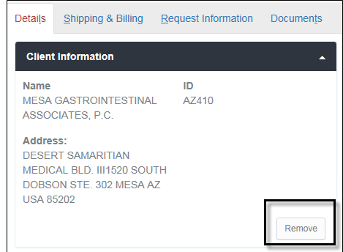

1. Select an option for locating the replacement.

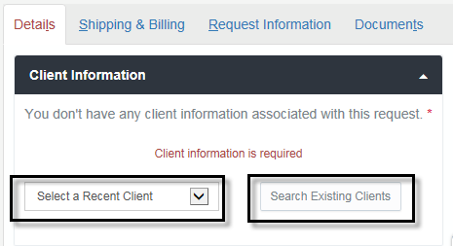

|  |  |
| --- | --- |
| **Clients recently used** | Click the field ***Select a Recent Client*** to open a list of clients you commonly use and highlight the name you want. |

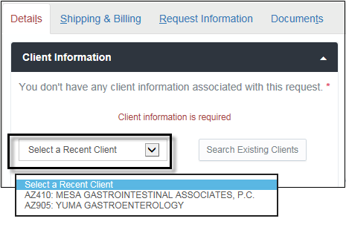

The system collects any number of clients ***you*** have used in previous requests. The listing is a function of your browser (for example, Microsoft Internet Explorer (IE) or Google Chrome). If you switch browsers, the system will begin creating a new list.

|  |  |
| --- | --- |
| **Clients not on the Recent list** | Click the field ***Search Existing Clients*** to open the search box. See the steps below. |

##### If you are an Administrator

You may have access to all clients. The search box opens.

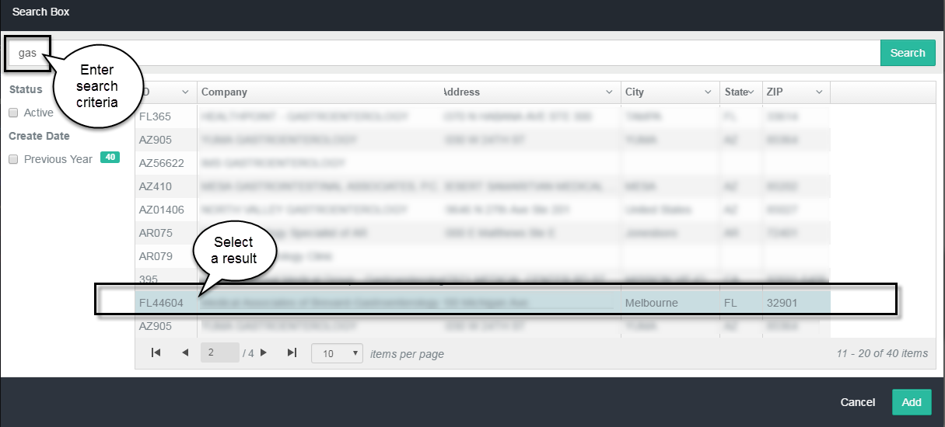

1. Type at least *three characters* in the text box and click **Search**.

HDS applies global searching. When the request contains partial information, the search will return all instances found in identification codes, company names, point of contact names, street addresses, cities, states, and zip codes.

|  |  |
| --- | --- |
| **Search facets** | When multiple records return, a set of filters (facets) is available to further narrow the results. Facets are common characteristics found within the set of results that can be used to group items on the list. The facets appear in the left column of the results screen. |
| **Sort the list of results** | To re-order (sort) the list of results, click the  **Disclosure** (down arrow) button in a column heading and select *ascending* or *descending* from the drop-down list. |

1. From the search results list, click to select the client and click **Add**. The client information is associated to the request and the search screen closes.

##### If you are not an Administrator

You may have access to a specific group of clients. The list of your authorized clients appears after clicking ***Search Existing Clients***.

1. Click a name to associate the client to the request.

The new client will appear in the ***Client Information*** section.

#### Add Patient Information

1. Enter at least the minimum patient information: *First Name*, *Last Name*, and *Date of Birth*.

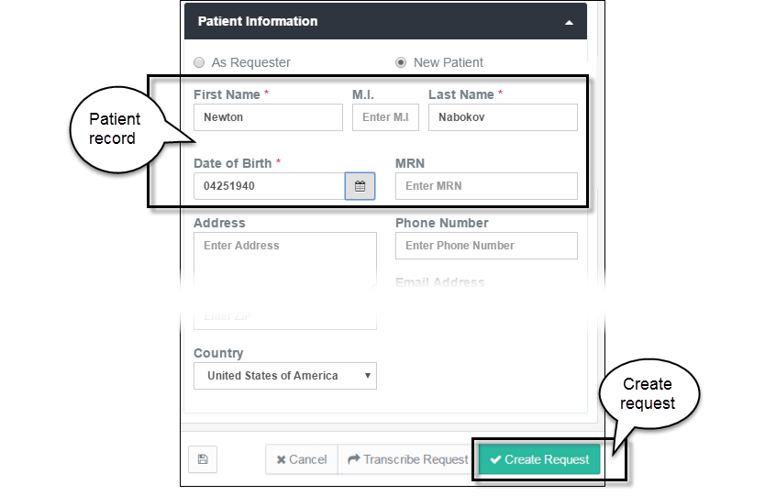

1. Click **Create Request**. The request moves to the ***Transcribe Queue***. The queue opens, showing the new request and the request number.

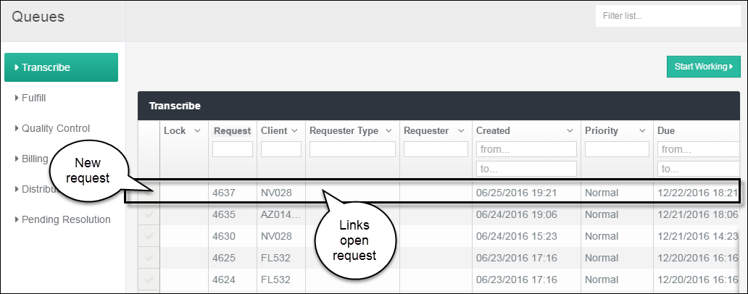

To return to the request page, click any column in the row of request details. Every column is a hyper-link that opens the respective request page. You can continue to add or to revise requests until complete.

## Batch – Group of Requests

This section describes the steps for uploading a batch of two or more individual requests.

***Quick Steps***

|  |  |
| --- | --- |
| 1. **Choose file(s)** | Click *Choose Files* to select files from your shared drives and folders. |
| 1. **Upload the files** | Click *Upload Files* to review the selected files in the ***Uploaded Files*** list. |
| 1. **Change Document Type(s)** | If necessary, change the document type(s) in the request. |
| 1. **Edit Batch** | Click *Edit Batch* to review and update the request. |
| 1. **Change** **Client Information** | If the default client needs changing, search for the name to complete the section. The Client automatically applies to every request in the batch. |
| 1. **“Create Request”** | Click the button to create requests numbers and automatically place all requests in the ***Transcribe*** queue. |

### Upload a Group of Documents

Start the request from the **+** **New** menu on the page banner.

1. Click the **New** icon to open the pop-up menu. `

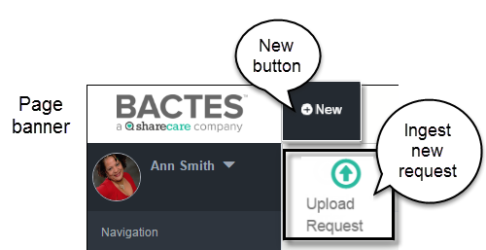

1. Click the **Upload Request** icon to open the request page.

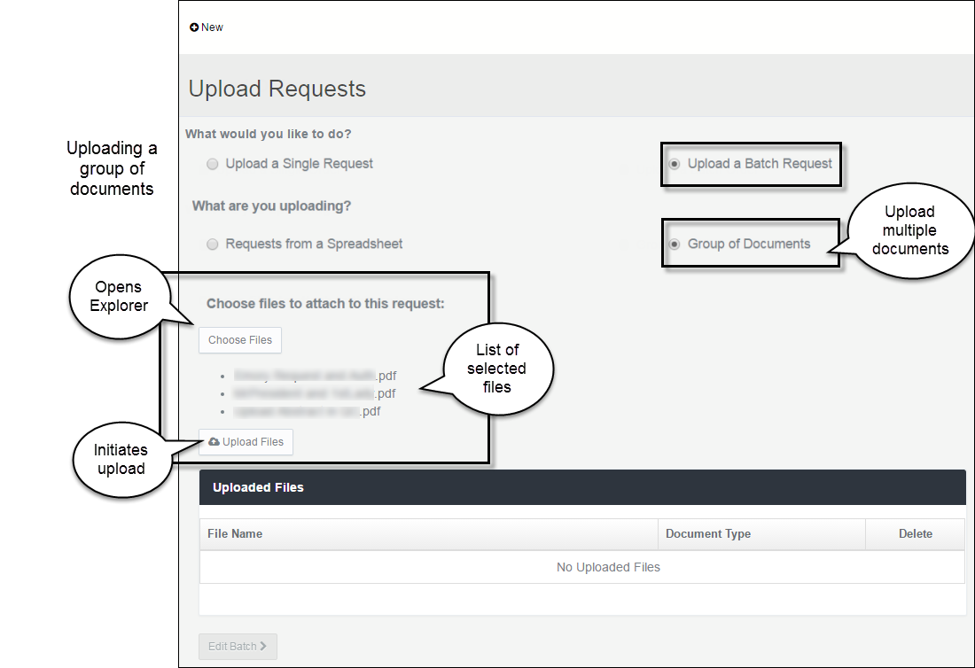

|  |  |
| --- | --- |
| *Group Request buttons* |  |
| **Upload a Batch Request** | In the section of the page titled *What would you like to* do*?,* select**Upload a Batch Request** (to send several requests)*.* |
| **Group of Documents** | In the section of the page titled *What are you* uploading*?,* select**Group of Documents.** |
| **Choose Files** | Click **Choose Files** to open Windows Explorer on your computer. |
|  | From a folder, select multiple files for upload and click **Open**. |
|  |  |
|  | **File Types**  All documents in the request package must be ***.pdf*** files. You can upload other file types (such as Microsoft Office or graphics) and HDS will convert them to *.pdf*. |
|  |  |
|  | The Explorer window closes and the names of the selected files appear in a bulleted list below the *Choose Files* button. |
| **Create the upload** | After verifying the files selected from your folder, click **Upload Files**. The file names reappear on the Uploaded Files list. |

To delete the entire selection of files before upload, click the ***Choose Files*** button. The Windows Explorer screen opens and the previously selected items are removed. You can reselect files or Cancel to discontinue the request.

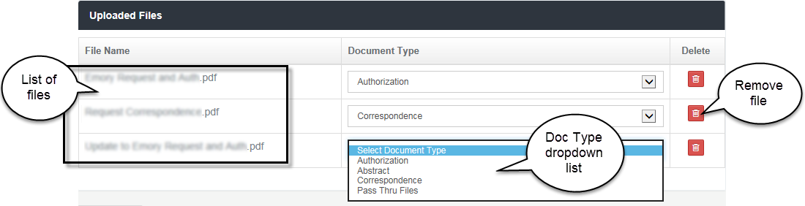

|  |  |
| --- | --- |
| **Document Type** | The ***Document Type*** default is ***Authorization***. To change a ***Document Type***, open the drop-down list and select another type. |

***Do you want to remove a file from the batch?***

Click the  Delete (trash can) icon corresponding to the file.

1. When the list of batch requests is correct, click the  button. The ***Create*** ***Batch Requests*** page opens.

### Create the Requests

When the batch successfully uploads, the **Create Batch Requests** page opens. You’re now ready to create the individual requests in HDS.

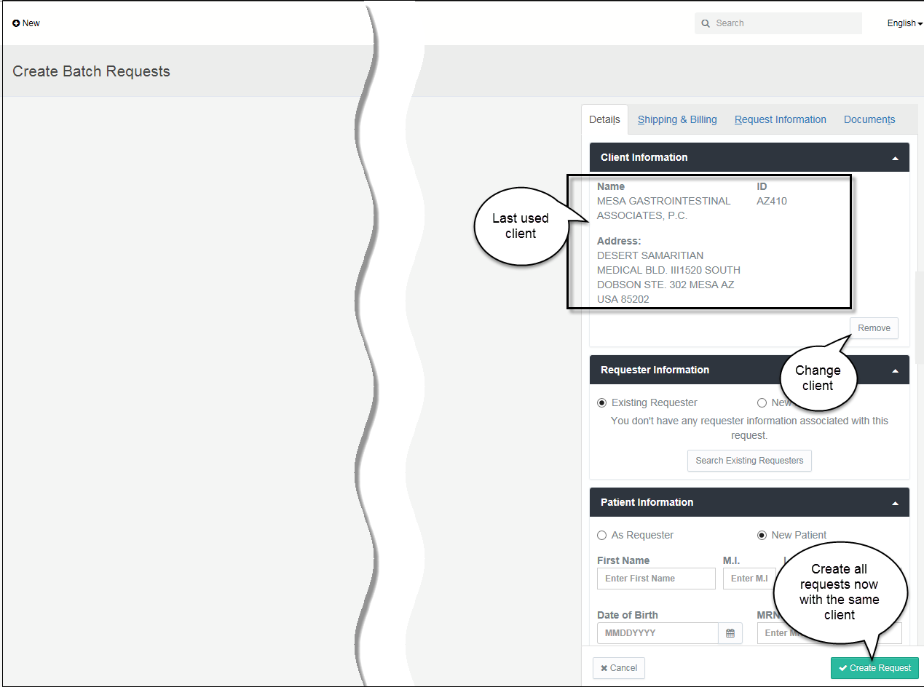

#### Do you want to change the client?

When creating a new request, the system pre-fills the ***Client Information*** section with the name of the client most recently used. The client is associated to every request in the batch. If necessary, you can associate a different client to all the requests.

1. Click the **Remove** button to change clients.



1. Select an option for locating the replacement.



|  |  |
| --- | --- |
| **Clients recently used** | Click the field ***Select a Recent Client*** to open a list of clients you commonly use and highlight the name you want. |



The system collects any number of clients ***you*** have used in previous requests. The listing is a function of your browser (for example, Microsoft Internet Explorer (IE) or Google Chrome). If you switch browsers, system will begin creating a new list.

|  |  |
| --- | --- |
| **Clients not on the Recent list** | Click the field ***Search Existing Clients*** to open the search box. |

##### If you are an Administrator

You may have access to all clients. The search box opens.

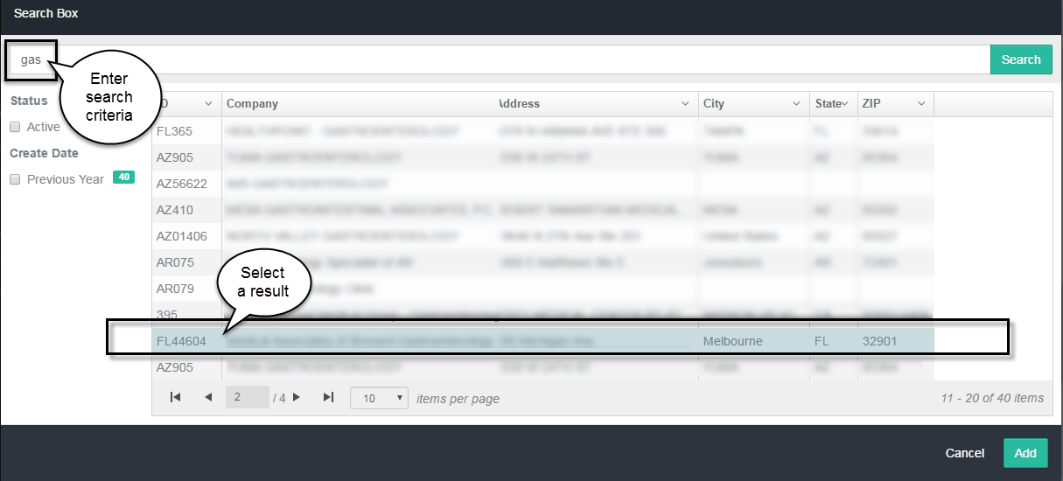

1. Type at least *three characters* in the text box and click **Search**.

HDS applies global searching. When the request contains partial information, the search will return all instances it finds in identification codes, company names, point of contact names, street addresses, cities, states, and zip codes.

|  |  |
| --- | --- |
| **Search facets** | When multiple records return, a set of filters (facets) is available to further narrow the results. Facets represent common characteristics found within the set of results that can be used to group items on the list. The facets appear in the left column of the results screen. |
| **Sort the list of results** | To re-order (sort) the list of results, click the  **Disclosure** (down arrow) button in a column heading and select *ascending* or *descending* from the drop-down list. |

1. From the search results list, select the client and click **Add**. The client information is associated to this request and the search screen closes.

##### If you are not an Administrator

You may have access to a specific group of clients. The list of your clients appears after clicking ***Search Existing Clients***.

1. Click to select a different client to associate to this request.

#### *Create Request* button

To automatically create all the requests and move them to the *Transcribe* queue, click ***Create Request***. (Jump to the section titled **Create Requests** below if you do not need to review the files or change document type.)

To see the list of files in the batch before moving to the *Transcribe* queue, change a file’s Document Type, or to view the contents of a file, open the ***Documents*** tab.

#### View the list of requests Individual

1. Click the ***Documents*** tab to view the list of requests.

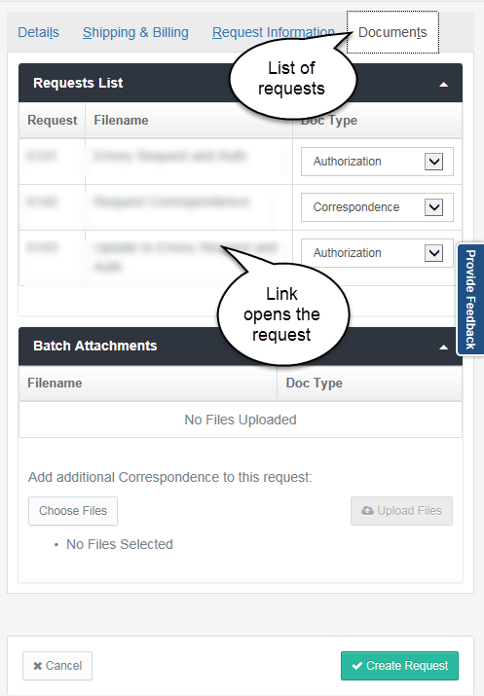

|  |  |
| --- | --- |
| **List of requests** | The ***Documents*** tab (in the detail frame on the right side of the page) shows the list of all the files in the batch.  While the requests may not yet be complete and formally created, the system assigns ***Request*** numbers to each document.  The ***Filename*** does not change; the system retains the name of the file uploaded from your local Explorer list.  From the ***Documents*** tab, you can also reassign ***Document Type***, if necessary. |

***Order of the documents***: The files are organized in the order they appear in your Windows Explorer list. HDS assigns consecutive Request numbers beginning with the first file on the list.

 If you want the requests to appear in another order, organize the filenames in Explorer before upload.

1. To change a document type, click in the ***Doc Type*** field and select a different type from the dropdown list.
2. To open the request, click a filename. The pages of the file appear in the content frame of the page.

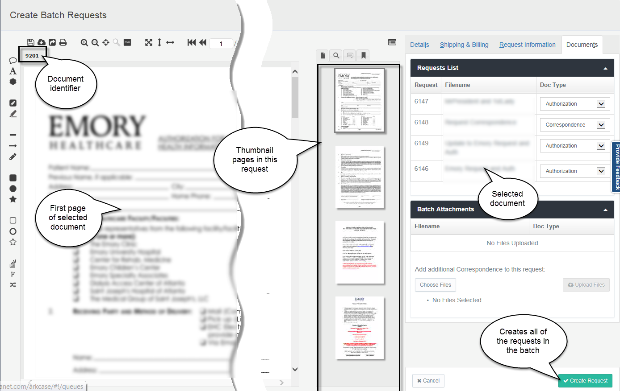

The screen shows the first page of the selected request, thumbnails of all pages in the request, and the tabs for updating the request details.

|  |  |
| --- | --- |
| *On the Create Batch Requests page* | |
| **Document identifier** | The system assigns a unique identifier to each document uploaded. The document number appears in a tab above the document display section of the page.  When you return to the request page, these tabs show at a glance the number of documents in the package. Click a tab to quickly open one of the documents. |
|  | ***What do these identifiers tell you?***  There is only one ***Authorization*** document and one ***Abstract*** document in a package. (The document title is the file name of the first document of the document type uploaded.) When subsequent files of these document types are added to the request, the pages of the uploaded files *append* the existing file—add pages to the total count.  Every piece of ***Correspondence***, which is not counted in the package page total, is stored as a separate document. A unique identifier tab is created for every correspondence document added to the request. |
| **Content frame** | A full view of the first page of the selected request appears in the left frame of the screen. |

|  |  |
| --- | --- |
| **Thumbnails frame** | All pages of the selected document appear in the narrow thumbnails frame in the center of the page. Click the thumbnails to move through the document and to view the page in the document display space. A toggle above the thumbnails hides the frame from view. |
| **Document details** | The ***Details*** tab does not require completion to formally create the requests from a batch of uploaded files. |

#### Create the Requests

1. Click **Create Request**. This request moves to the ***Transcribe Queue***.

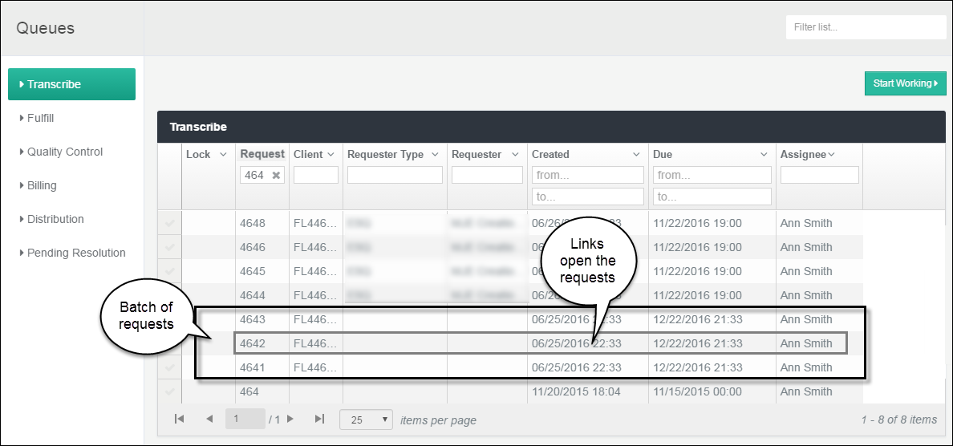

The request numbers are consecutive. Every request is assigned the same client, create/due date, time, and priority.

Open each request to complete the transcription. To return to the request page, click any column in the row of request details. Every column is a hyper-link that opens the respective request page. You can continue to add or to revise requests until complete.

## Batch – Spreadsheet of Requests

This section describes the steps for uploading and creating multiple requests from a single spreadsheet. The uploaded spreadsheet contains columns with all required request information.

***Quick Steps***

|  |  |
| --- | --- |
| 1. **Choose file** | Click *Choose Files* to select a single spreadsheet from your shared drives and folders. |
| 1. **Upload the spreadsheet** | Click *Upload Files* to open and view the spreadsheet content in the ***Uploaded Files*** list. |
| 1. **Edit Batch** | Click *Edit Batch* to open the *Create Batch Request…* page. |
| 1. **Create Request** | Click *Create Request* to create a request number for every item in the spreadsheet and automatically place the requests in the ***Transcribe*** queue. |

### Upload Spreadsheet

Spreadsheets transmit multiple requests in a single file. HDS permits two file types: *.xls/x* Excel files and *.csv* files. (EPIC users transmit .*csv* files.)

Start the request from the **+** **New** menu on the page banner.

1. Click the **New** icon to open the pop-up menu.

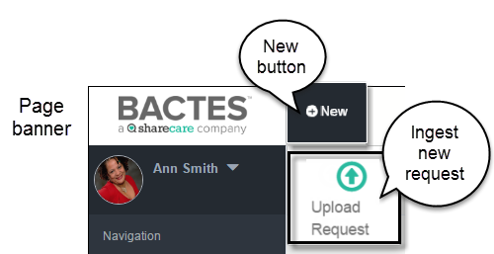

1. Click the **Upload Request** icon to open the request page.

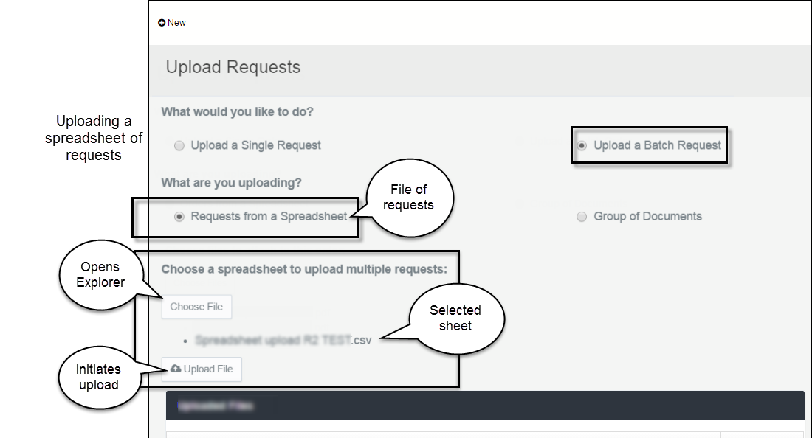

|  |  |
| --- | --- |
| *Requests from Spreadsheet buttons* | |
| **Upload a Batch Request** | In the section of the page titled *What would you like to* do*?,* select**Upload a Batch Request*.*** |
| **Requests from a Spreadsheet** | In the section of the page titled *What are you* uploading*?,* select**Requests from a Spreadsheet.** |
| **Choose File** | Click **Choose File** to open Windows Explorer on your computer. |
|  | If necessary, open the folder, then select a spreadsheet and click **Open**.  The Explorer window closes and the name of the selected Excel or *.csv* file appears as a bulleted list item below the *Choose Files* button. |

To delete the selected file before upload, click the ***Choose File*** button. The Windows Explorer screen opens and the selected file is removed. You can select a file or Cancel to discontinue the request.

|  |  |
| --- | --- |
| **Upload File** | Click **Upload File** to show the requests (content of the spreadsheet) in a list on the screen. |

#### Required Information for Creating Requests

The headings highlighted below mark the information that the spreadsheet must contain.

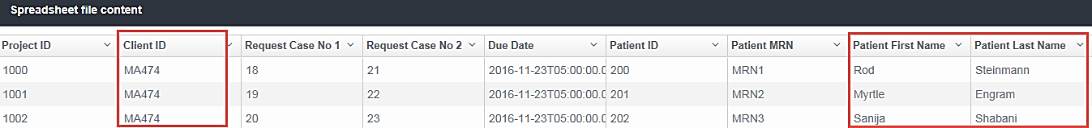

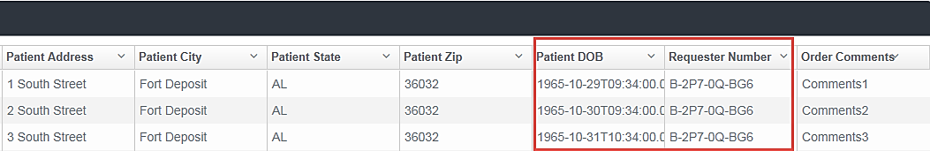

#### Viewing the batch list before creating the requests

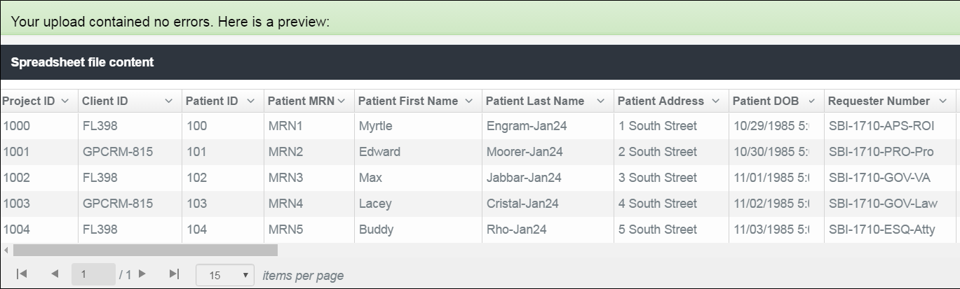

* To hide a column from view, click the  **Disclosure** (down arrow) button in a column heading and select **Hide Column**.

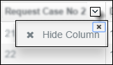

* To close the pop-up, click the small **X** at top-right in the button.

1. To start the request process, click the  **Edit Batch** button. The ***Create*** ***Batch Requests from Spreadsheet*** page opens.

### Create the Requests

After successful upload, the ***Create Batch Requests from Spreadsheet*** page opens.

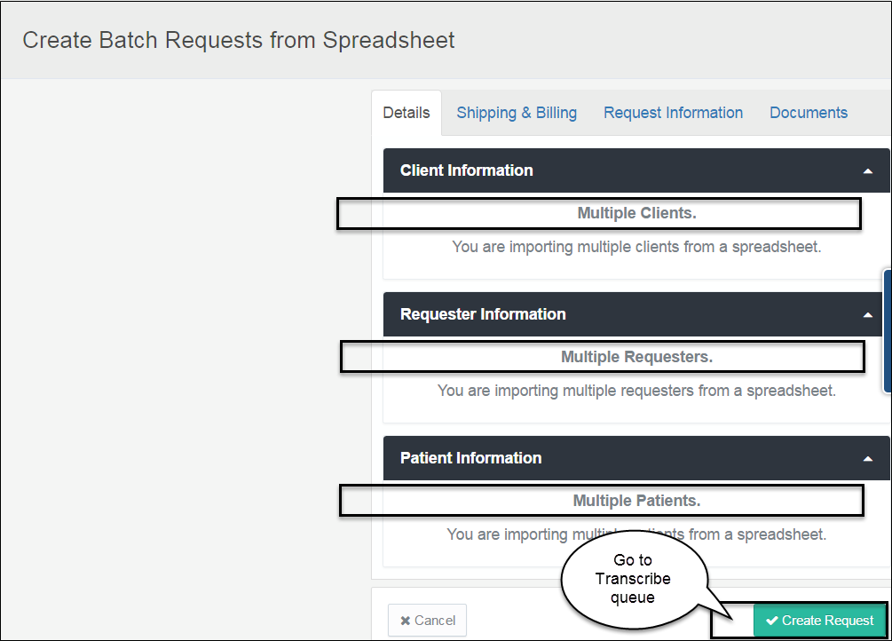

The ***Create Batch Requests*** page above represents a spreadsheet containing multiple types of information.

***Request Details***

Information fills in this page only if it is common to all new requests in the spreadsheet.

1. Click **Create Request** to assign request numbers to each item in the batch and move the new requests to the ***Transcribe Queue***.

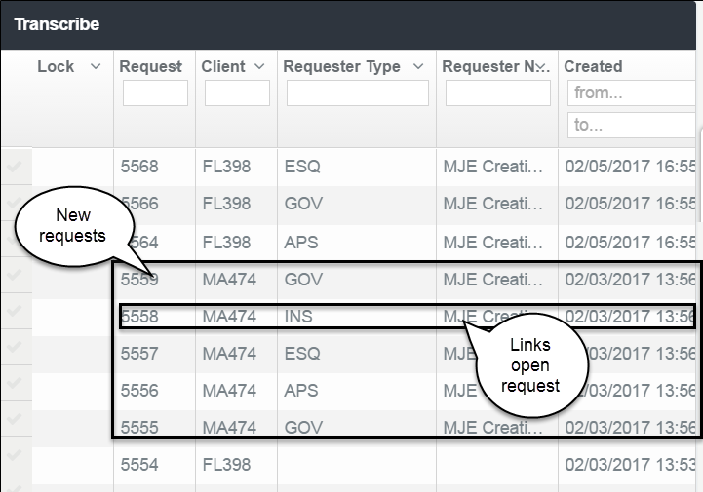

The request numbers are consecutive. All detail from the spreadsheet is uploaded into the requests, such as client, requester and requester type, due date, and priority. The system fills the create dates and times, and the assignee.

1. To open an individual request and complete the details (Transcribe), click any column in the row of request details. Every column is a hyper-link that opens the respective request page.

The request summary appears at the top of each request page.

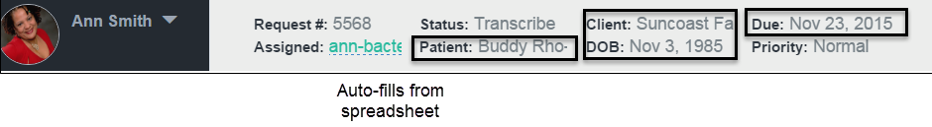

The Patient Information from the spreadsheet fills in the associated request. The ***Details*** tab is open.

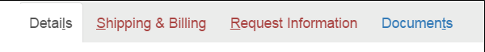

Depending on the content of the spreadsheet, the detail tabs in red indicate the initially required information. The fields in the tabs are marked with a red asterisk *.

* To add the supporting files, click the ***Documents*** tab.

# 

# Document Management

You can update documents at any time throughout the request process. From the request page, you can view and modify the documents until the request is considered complete and marked for delivery. Access to the documents and use of document management functions depend on the Queue in which the request currently exists and on the permissions of the current assignee.

Topics in this chapter

**Viewing Request Documents**

View the documents from the Request page or in the Document Viewer.

**Working with Document Pages**

Options available to existing pages.

**Adding Files**

Continue adding to the package after the request is created.

**Versioning Files**

HDS automatically creates versions after specific actions are taken.

**Managing Request History and Notes**

The system collects actions taken on each request. The system also stores notes with requests.

**Setting Document Preferences**

You can customize the document review tools to your preference.

## View Package Documents

Every document (file) in the request is available for view. The system creates a tab (numbered at top left above the displayed page) identifying each individual document in the request: one Authorization document, one Abstract document, and individual Correspondence documents.

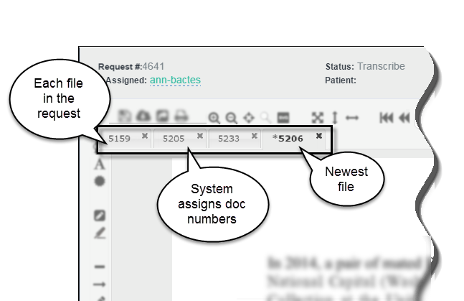

|  |  |
| --- | --- |
| **Numbered tabs** | The repository assigns a unique number to each document at the time it is saved. These identifiers appear in the tabs above the page display space. The system-generated numbers are not formally associated with the request and they are not search-able. |



Every request has 1 Authorization document and 1 Abstract document. All added files append the original document. Each piece of Correspondence creates a separate document.

To view a file in the request, click the ID number tab.

### Document Viewer (Virtual Viewer)

The Viewer opens the document, thumbnails of its pages, and document tools in a new window.

To view files in the document viewer, click the  viewer icon. (The button is at far top-right on the Request page, below the ***Search*** box.)

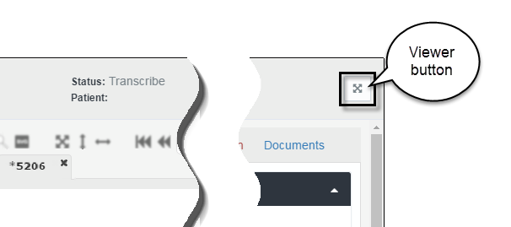

***Narrow the number of package documents in view***

By default, all documents in the request are available for viewing.

1. Click the ***Documents*** tab in the details frame. Notice that all documents are automatically selected (check marked).

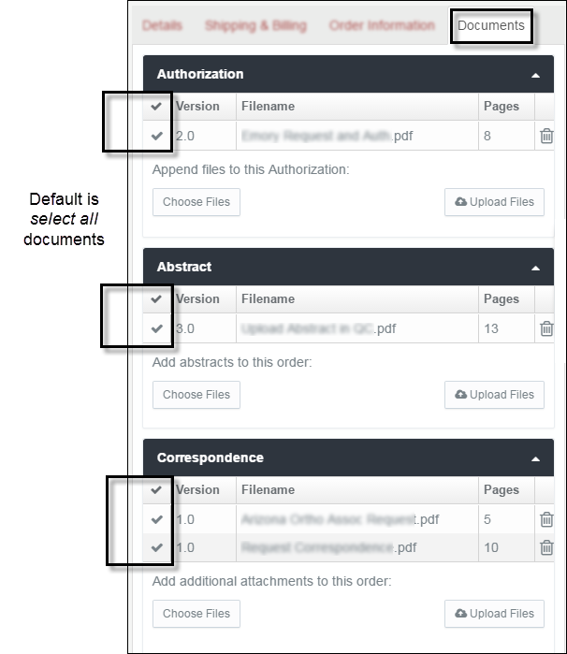

1. Click each file to un-check it, leaving only the file you want to view.

## Work with Pages

This section provides tips about navigating request pages and acting on page content.

### Shortcut keys

When a request is open on the screen, you can move through the form without using the mouse. Like Microsoft Windows, HDS identifies the keyboard shortcuts by an underlined alphabetical letter in the label. The example below is the set of detail tabs in the Create Request page.

#### Document detail tabs



Move between tabs and tasks by pressing these keys.

|  |  |
| --- | --- |
| Details tab | ALT+L |
| Shipping and Billing tab | ALT+S |
| Request Information tab | ALT+R |
| Documents tab | ALT+T |

#### Document view and navigation

Press keys Ctrl + / to see the list of keyboard shortcuts, like the example below.

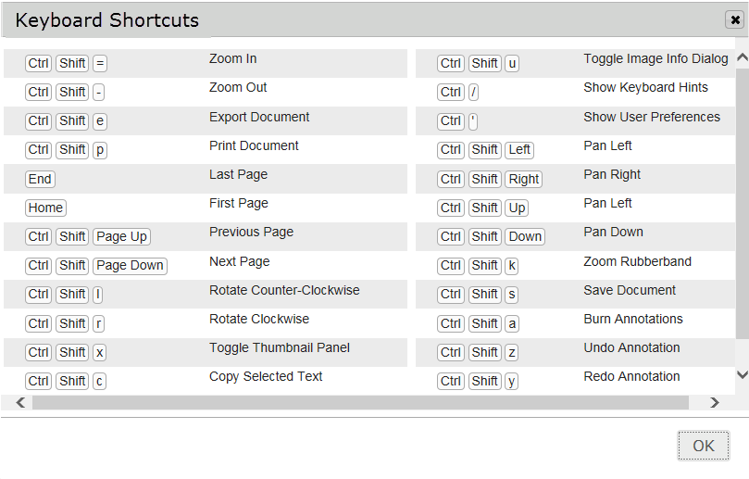

#### Page actions

The menu below shows the options available for use in pages.

* To open the menu, right-click the page in the thumbnails list.

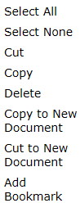

These functions are standard editing options. For use in requests, the actions apply to pages, not to the content of pages.

### Actions affecting page count

Actions such as *delete*, *copy to new document*, and *cut to a new document* create a new version of one or more documents. (See the section ***Create File Versions*** later in this chapter.)

### Delete Page

To delete, select a page (or more than one by holding ***Ctrl***) from the thumbnails frame and click the **Delete** key. The **Delete Pages** dialog box opens.

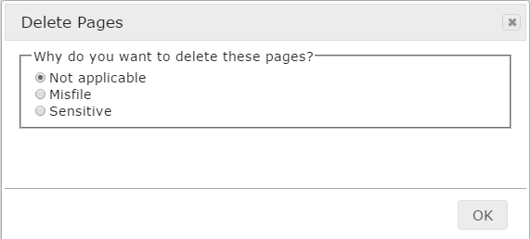

If reason is **Misfile**, enter the **Patient Details** in the text boxes.

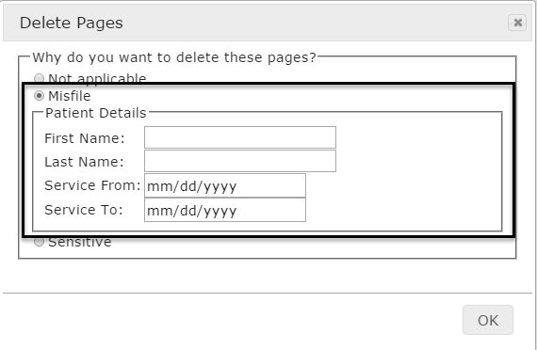

* Type in patient name. A calendar picker is available from the Service From and To date fields.
* Click **OK**.

If reason is **Sensitive**

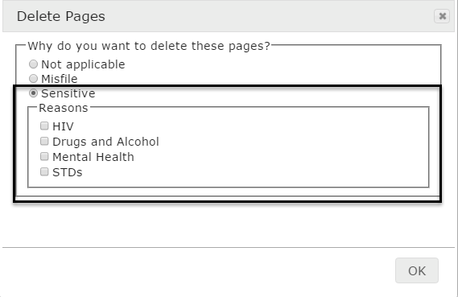

* Select one or more checkboxes that apply.
* Click **OK**.

Click the **Save Document** icon to make the delete action final.

The system updates the **Documents** tab.

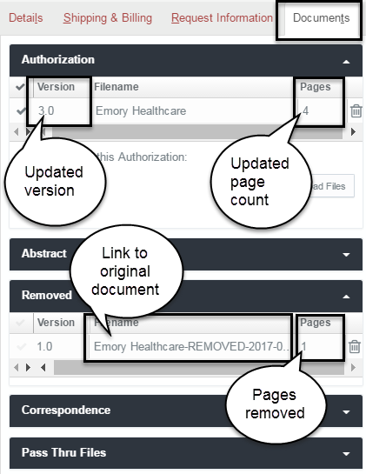

* Document version increments by 1 and the page count is reduced.
* Document name (link to the original version) and the number of pages deleted appear on the ***Removed*** list

**Note**: The process of deleting a page can affect non-.pdf file conversion. See the section ***Add Other File Types*** for a warning about taking the two actions simultaneously.

## Add Files

This section describes the steps for adding files to a request.

On the request page, select the **Documents** tab in the right frame of the screen.

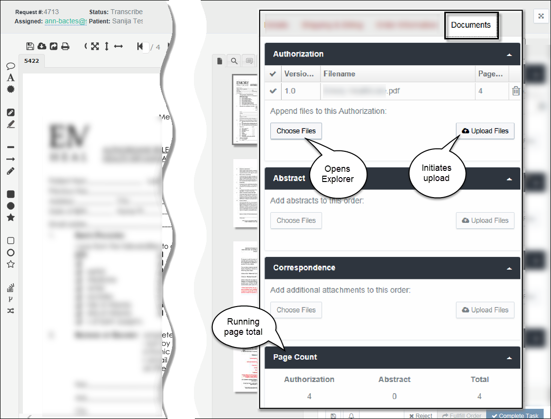

|  |  |
| --- | --- |
| *Add Document buttons* | |
| **Choose Files** | Click **Choose Files** to open Windows Explorer on your computer. |
|  | From a folder, select the file(s) for upload and click **Open**. |
|  |  |
|  | **File Types**  All documents in the request package must be ***.pdf*** files. You can upload other file types (such as Microsoft Office or graphics) and HDS will convert them to *.pdf*.  For further information, see ***Add Other File Types*** in this chapter. |
|  |  |
|  | The Explorer window closes and the name of the selected file(s) appears in a bulleted list below the *Choose Files* button. |

To delete the entire selection of files before upload, click the ***Choose Files*** button. The Windows Explorer screen opens and the previously selected items are removed. You can reselect files or Cancel to discontinue uploading.

|  |  |
| --- | --- |
| **Upload Files** – Authorization & Abstract | Click **Upload Files** to create (or append) one or more ***Authorization*** or ***Abstract*** files.  The individual uploaded pages appear in the thumbnails frame. |
| **Upload Files** –Correspondence | Click **Upload Files** to add one or more ***Correspondence*** files. |

***When adding files…***

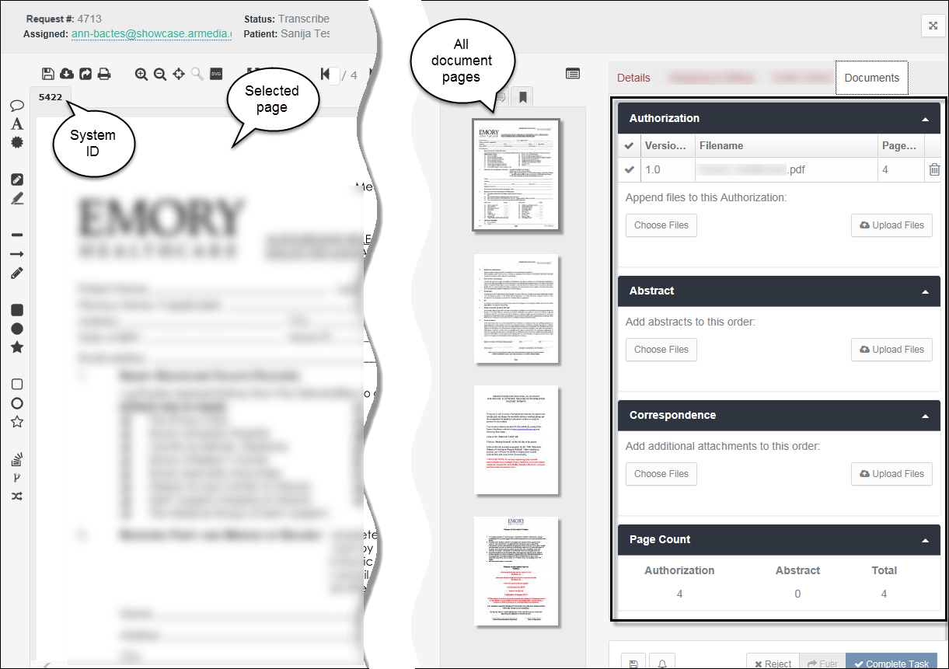

|  |  |
| --- | --- |
| *Document Type* |  |
| **Authorization** | If no existing file, the uploaded document is added as version 1. |
| **Abstract** | If no existing file, the uploaded document is added as version 1. |
|  | If an ***Authorization*** or ***Abstract*** file exists, the uploaded document *appends* the existing document—its pages are added to the existing pages. The document version will increment by 1 (or by the number of files added). |
| **Correspondence** | All files are added as separate documents. |

### Add Authorization Documents

You can upload more than one file. If you are creating a new Authorization document, the **file name** defaults to the *first* file in the batch.

HDS orders the files as they appear in Windows Explorer. By default, files in Windows Explorer folders list in ascending alphabetical order. When the folder opens in your Explorer window, sort the files *before* selecting and uploading to create the file name you want.

Files added to an Authorization ***append*** the existing pages.

***Record of Authorization document***

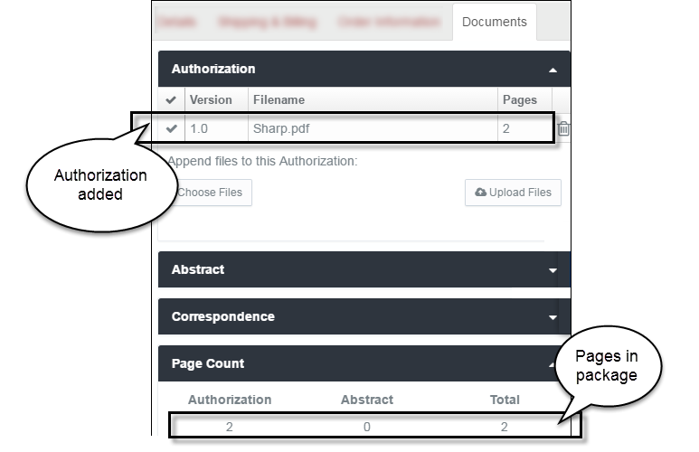

The additional pages are visible in the thumbnail frame. The pages are placed after the existing pages.

|  |  |
| --- | --- |
| *File status* |  |
| **Version** | The *Version* of the new ***Authorization*** file is 1. When uploading multiple files, the version increments by the number of documents added. For example, adding four Authorization files in the initial upload will automatically create version 4. |
| **Filename** | The *Filename* will not change, it remains the name of the original, or first, uploaded file. |
| **Pages** | The *Pages* count increments by the number of pages added to the file. |

* To remove the file from the request, click the  **Delete** (trash can) icon.

### Add Abstract Documents

You can upload more than one file. If you are creating a new Abstract document, the **file name** defaults to the *first* file in the batch.

HDS orders the files as they appear in Windows Explorer. By default, files in Windows Explorer folders list in ascending alphabetical order. When the folder opens in Explorer, sort the files *before* selecting and uploading to create the file name you want.

Files added to an Abstract ***append*** the existing pages.

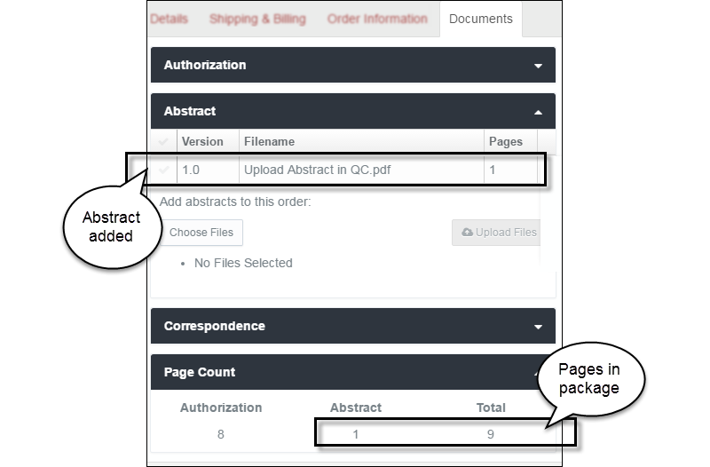

The additional pages are visible in the thumbnail frame. The pages are placed after the existing pages.

|  |  |
| --- | --- |
| *File status* |  |
| **Version** | The *Version* of the new Abstract file is 1. When uploading multiple files, the version increments by the number of documents added. For example, adding four Abstract files in the initial upload will automatically create version 4. |
| **Filename** | The *Filename* will not change, it remains the name of the original, or first, uploaded file. |
| **Pages** | The *Pages* count increments by the number of pages added to the file. |

***Do you want to remove a file from the request?***

Click the  **Delete** (trash can) icon corresponding to the file name.

### Add Correspondence Documents

Each new Correspondence document is added as a separate file.

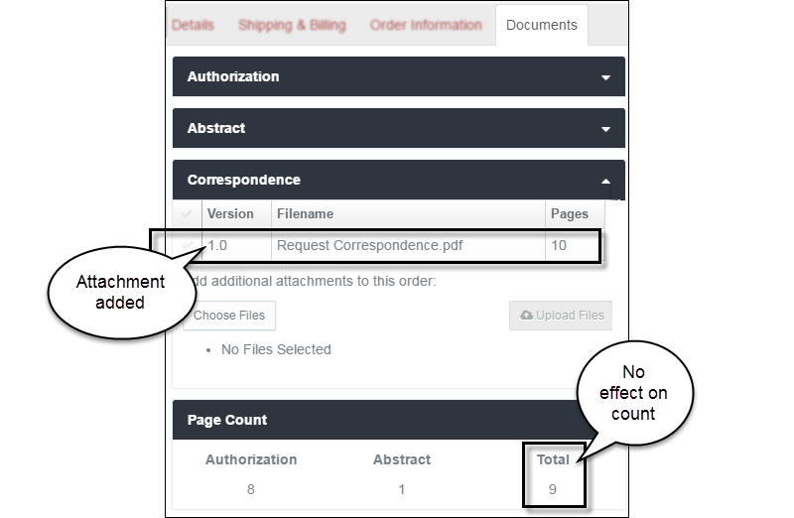

|  |  |
| --- | --- |
| *File status* |  |
| **Version** | The *Version* of added Correspondence is always 1. |
| **Filename** | The ***Filename*** column is a record of each Correspondence document. You can add multiple documents at a time, which are individually added to the Filename list. |
| **Pages** | Correspondence does not affect the package *Page Count.* |

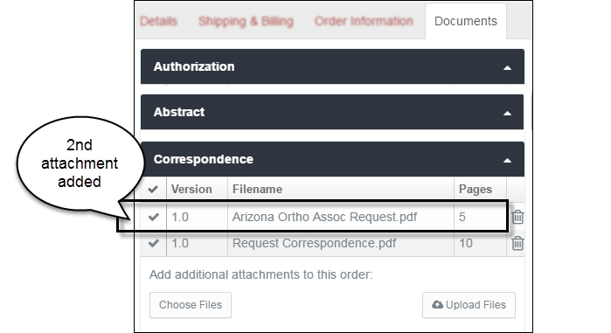

***Do you want to remove a file from the request?***

Click the  **Delete** (trash can) icon corresponding to the file name.

### Add Other File Types

All documents in the HDS request package are *.pdf* files. When you upload other file types—such as Microsoft Word, PowerPoint, Visio, and Excel; graphics; or .*tiff/.tif* — HDS converts them before opening a new request page, appending an existing document, or creating new correspondence.

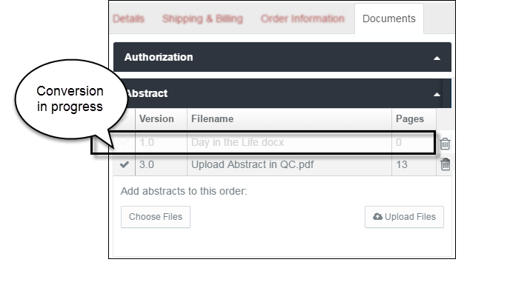

The conversion is not instantaneous. Expect the file to convert and load in 1 to 2 minutes.

During the process, the file name appears ***dimmed*** on the ***Filename*** list. When the conversion completes, the file name disappears and the pages append to the existing file or a new Correspondence document is added.

**Warning: converting a file and deleting a page…**

Wait for the conversion to complete before you **delete a page** from the file you are appending. A page delete prevents the conversion from completing and prevents the pages from being appended to the existing file. The interruption to the conversion, however, does not prevent versioning. The version will increment by one even though the file was not updated. (See ***Create File Versions***, the next section, for guidelines on document versioning.)

## Create File Versions

This section describes the actions that create versions of files.

* **Append files**
* **Annotate files**
* **Change the number of pages in a file**

Open the request. Select the **Documents** tab in the right frame of the page.

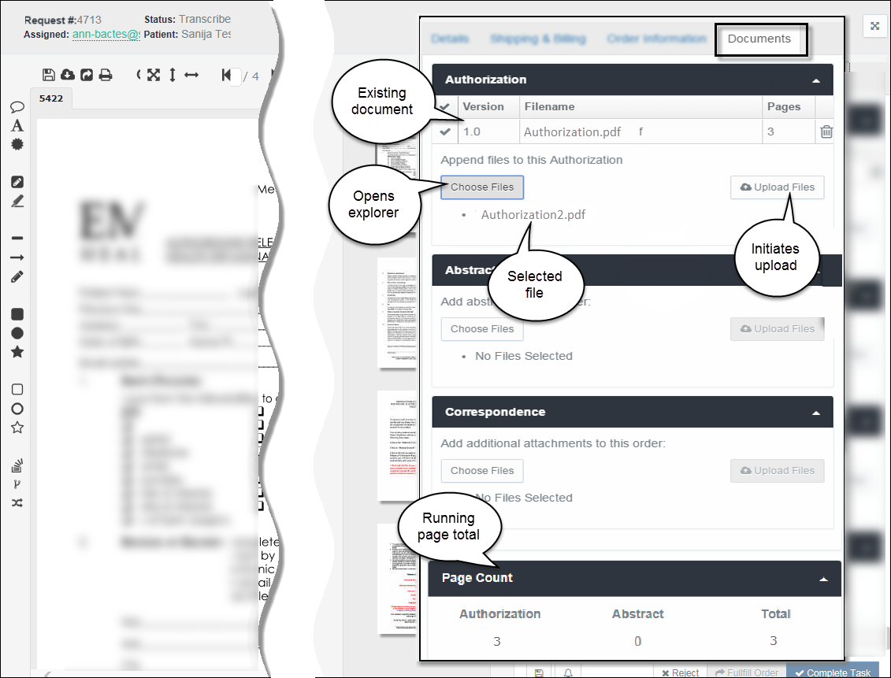

In this example, an Authorization document exists. Two actions create new versions of a document: ***Append*** and ***Edit*** (Save or Burn).

### Create Version - Append File(s)

File appending applies to ***Authorization*** and ***Abstract*** documents. When you add a file, you are inserting the pages from the file into the request package.

* Uploading one file increments the version number by 1.
* Uploading multiple files increments the version number by the number of documents selected. Four documents uploaded to a version 1 file creates version 5.

For further description of appending files, please see the section ***Add Files***.

| ***Authorization and Abstract Documents*** | |
| --- | --- |
| *Document detail buttons* | |
| **Choose Files** | Click **Choose Files** to open Windows Explorer on your computer. |
|  | From your drives and folders, select one or more files for upload and click **Open.**  The Windows Explorer screen closes and the name(s) of the selected file(s) appears as a bulleted list item below the *Choose Files* button. |

To delete the entire selection of files before upload, click the ***Choose Files*** button. The Windows Explorer screen opens and the previously selected items are removed. You can reselect files or Cancel to discontinue uploading.

|  |  |
| --- | --- |
| **Upload Files** | Click **Upload Files** to append the *Authorization* or *Abstract* file.  The file(s) pages appear in the thumbnail frame, after the existing pages.  The version of the file increments by 1 (or by the number of files uploaded). |

The version and the page count updates.

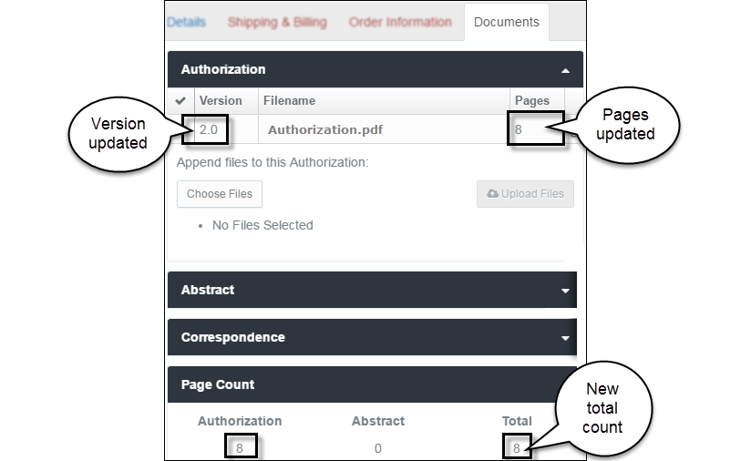

### Create Version – Annotate File

From the Request page, you can create, share, save, and burn a variety of document annotations.

#### Annotation Options

Open the request. The document most recently added to the request appears in the content space.

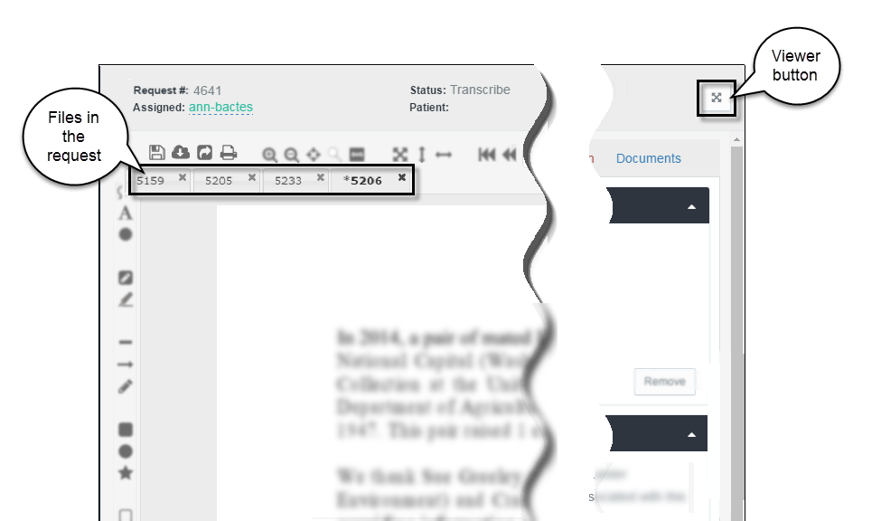

A set of annotation tools is available for *marking up* pages. The tools appear on the left pane of the request page in the document viewer (virtual viewer).

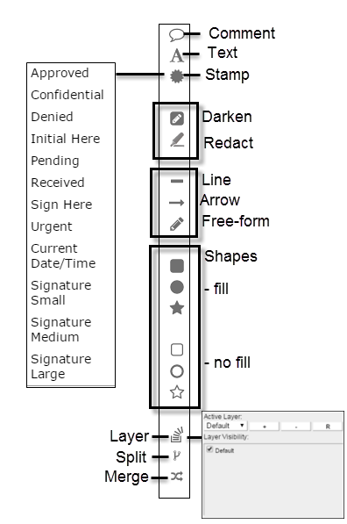

Each authorized reviewer can insert comments, highlights, and redactions for view by other authorized reviewers.

**Note**: Annotations added to documents in the ***Transcribe*** queue must be saved/burned for other reviewers to see them.

#### Arrow Annotation

When the user selects it, the arrow 🡪 annotation remains active until another annotation is selected.

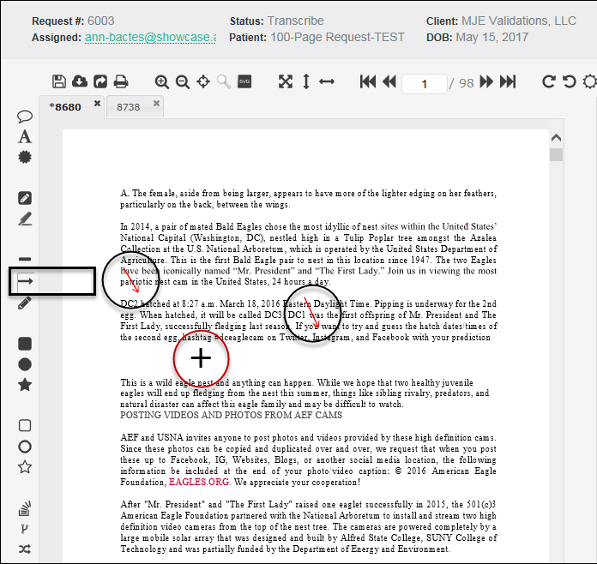

Any number of arrows can be added to the page or document without need to reselect the arrow icon. Once a document is in the QC stage, annotations are burned in and cannot be removed.

**Save and Version**

Annotation action buttons are at the top of the content space, above the document identifier tabs.

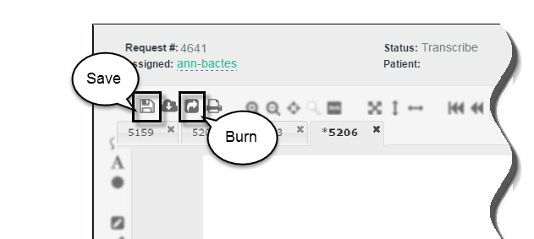

When markup is complete, click **Save Document** (to save annotations within the virtual viewer) or **Save Document** and **Burn Annotations** (annotations will print in the request package). Saving creates a new version of document. Page annotation is also available to Correspondence pages.

**Note**: Manual Save/Burn of annotations is required only in the Transcribe queue. Annotations are automatically burned when documents are in the Quality Control queue.

### Create Version – Change the File Page Count

You will create a new version of a document when you:

**Delete a page from a document** **|** Increments the version and changes the page count

**Cut a page and add it to another document** **|** Increments the versions of both documents and changes the page count of both documents

**Copy a page to another document** **|** Increments the version of the destination document and changes the page count of the destination document

## Manage History and Notes

HDS automatically records all actions taken on a request. Authorized users can attach notes to the request and make the notes available for other users to view.

The two tabs appear at the bottom of the document view space on the request page.

***I don’t see these tabs on the page.***

If the tabs don’t appear on the screen, they are hidden below the frame of the page. Go to the lower border of the page and click/scroll below the page display space.

The browser you are using (such as Internet Explorer, Chrome, Firefox) and the zoom setting of the browser (such as 75%, 100%, 125%) affect the appearance of these tabs on the page.

### Request History

All request “events” are collected in a list. Your system administrator designates the actions to track.

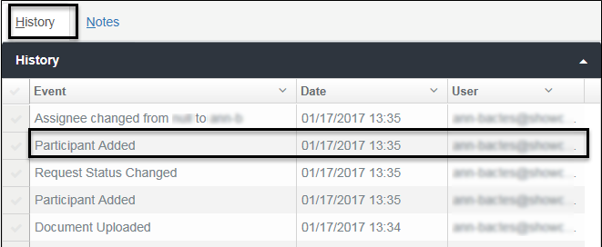

The History list identifies the event, the date of the event, and the user who took the action. The content is strictly for information purposes. No links or other uses are available.

### Request Notes

You can attach notes to a request. Notes create a record that is available to other people with access to the request.

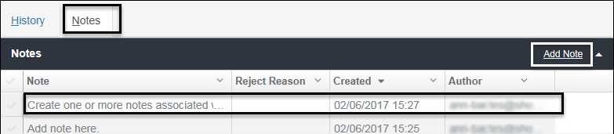

The screen shows the content of each note (truncated if too long for the description field), the date of the note, and the author of the note.

***Reject Reason***: A reason is required when rejecting a request. Rejection descriptions and reasons store in the Notes list.

To create a note, click the **Add Note** link on the title bar. A free form space opens for typing the description and saving (or canceling) the new note.

**Sorting the History and Notes Lists**

To reorganize the list, click the  **Disclosure** (down-arrow) button in a column heading to select an option.

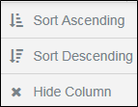

The default sort normally is descending by date/time.

## Set Document Preferences

You can create your own settings for the tools and screen display in the document viewer. You can create settings for:

* Toolbar
* Annotations
* Custom text stamps
* Display size

1. To personalize document review settings, open a request.
2. From the action buttons above the document content space, click the **User Preference** icon.

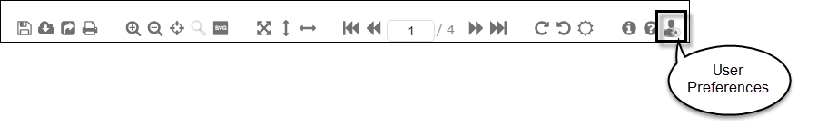

1. Click the tabs to set various doc review options.

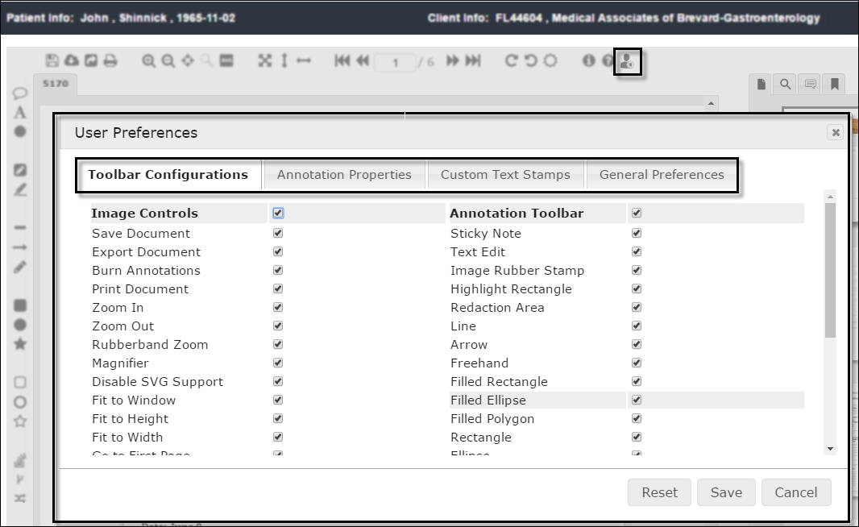

### Toolbar Configurations

All toolbar options are selected by default (screen shown above).

Unselect any of the tools you do not want to appear in your version of the virtual document viewer.

### Annotation Properties

Create settings for the annotation tools.

1. Select each ***Annotation Type*** you want to customize.

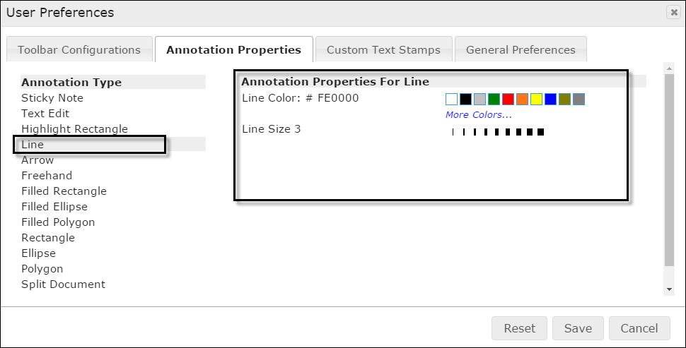

1. When the type is selected from the list, define the new properties using the setting on the right side of the screen.

### Custom Text Stamps

Create your own stamps.

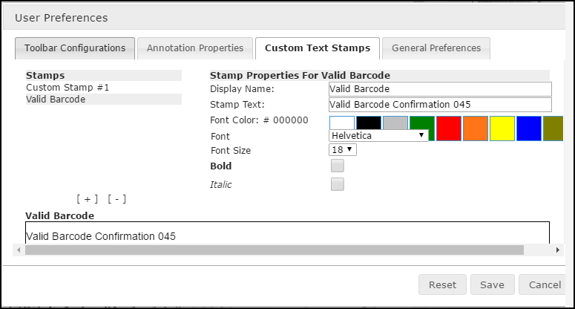

1. Click **[ + ]** (bracket plus sign) to create a new stamp.
2. Type a name for the stamp in the ***Display Name*** field in the properties section at right. The name appears in the ***Stamps*** list.
3. Type text that the stamp will display in the document.
4. Define the font, if needed.
5. To delete a stamp, highlight it in the ***Stamps*** list and click **[ - ]** (bracket minus sign).

### General Preferences

Change the display-fit and user name settings.

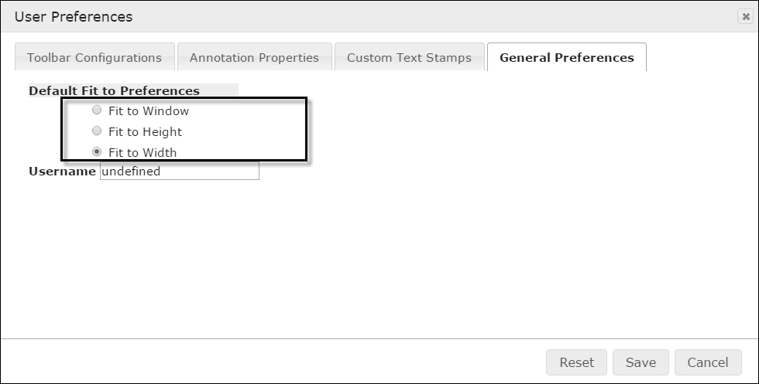

Click in a radio button to change the default document display.

### Saving and Resetting

1. Click Save to make the changes effective.
2. Click Reset to change the settings to the previous selections.
3. Click Cancel to close the window without saving.

# 

# Search

HDS makes available *global* search of all in-progress and archived request records. The search initiates:

* **User-defined search**
* **Pre-defined search**
* **Client and Requester search**
* **Queue content search**

You can create specific searches by entering *whole* words and numbers or filtered searches by entering partial words and numbers in the **Search** free-form text box.

Search *facets* accompany the results. These filters provide a way to narrow broad sets of results.

When running searches, you have access only to those results that you have permission to see.

Topics in this chapter

**Create a global search**

Using the search text box in the page banner.

**Filter pre-defined results**

Using the Search module to locate content.

**Search clients and requesters**

Using search to locate organizations and auto-fill its information.

**Options for the search results**

Viewing, organizing, and saving search results.

**Search queues**

Locating and grouping queue content.

## Global Search Text Box

Use the **Search box** to *define* a search. The text box is in the page banner and available anywhere in HDS.

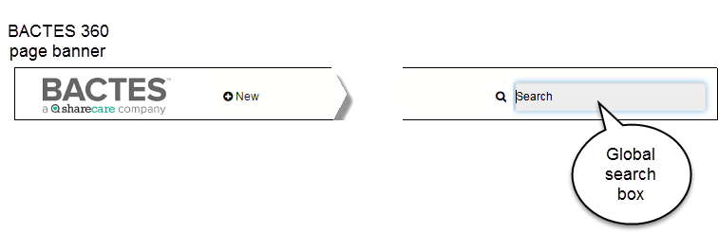

1. Type at least *three* letters or numbers for general searching. The results will include every instance of the search request it finds in the repository.

**Wild Card**

Use of the wild card—the **\*** asterisk—gives you further search options. The minimum requirement for a search request is three characters (letters or numbers). Two letters or numbers *plus* the asterisk (ja* or 48*) searches for all instances of the two characters—results beginning with, ending with, or otherwise containing.

|  |  |
| --- | --- |
| *Examples of  search request* |  |
|  | A search for full name returns only instances in which the name appears as entered. |
|  | Shortened name returns all instances (in names and within requests) of these three letters.  Same rule for search of numbers. All instances of three, four, or more numbers in requests, cases, identification, phones, faxes, addresses, dates, and times. |
|  | Use the **\*** to search for one or two characters or numbers. In the example, for all numbers including the digits *46*. |

1. To start searching, click **Enter** or the magnifying glass icon. The ***Search*** module page opens with the Results.

For a look at the results page, see the **Search Results** section below.

## Search Module

The **Search** module initiates a *pre-defined* search. When you click the ***Search*** tab in the Navigation frame, it automatically lists *all* available, searchable data in the repository.

* Click **Search** from the ***Navigation*** frame to open the module.

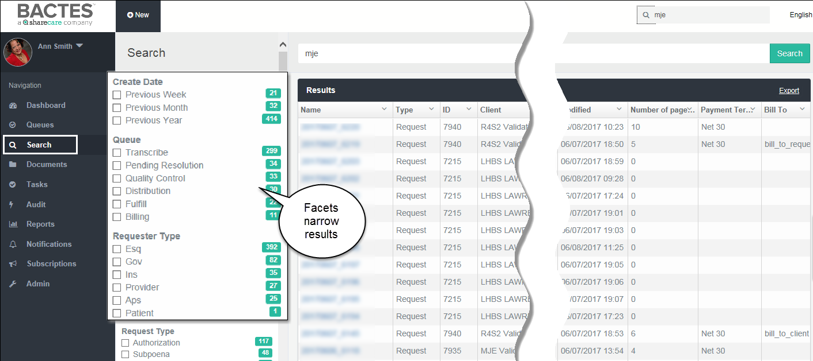

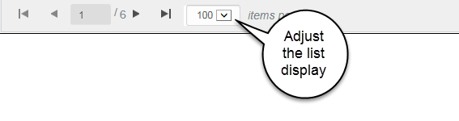

The results you see are collected only from those organizations with which you are authorized to work.

For a look at the results page, see the **Search Results** section below.

## Client and Requester

Requests require client and requester. Employees with broad permissions—that is, having access to most or all the CMR database—can use a special search to locate and upload these associations.

Employees with limited permissions see a pre-defined search results list of those organizations with which they are authorized to work.

This search initiates from the ***Details*** section (***Client*** or ***Requester***) of the request.

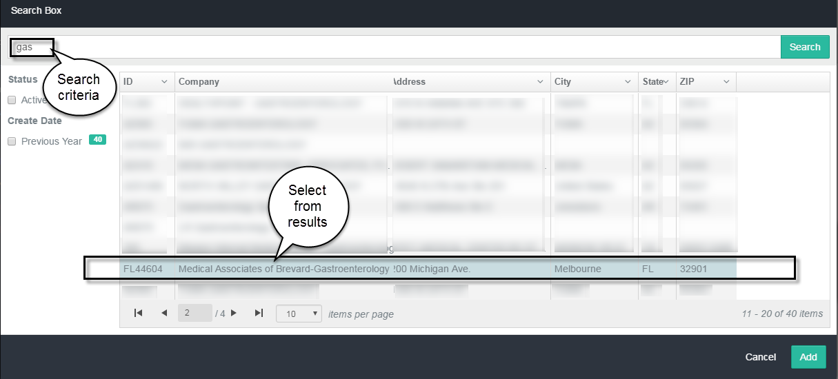

The standard rules apply when defining the search: the request must contain at least three characters.

If multiple results return, click to select the correct item from the list and click **Add**.

## Search Results

The options for reviewing search results are similar, regardless of how the search initiates.

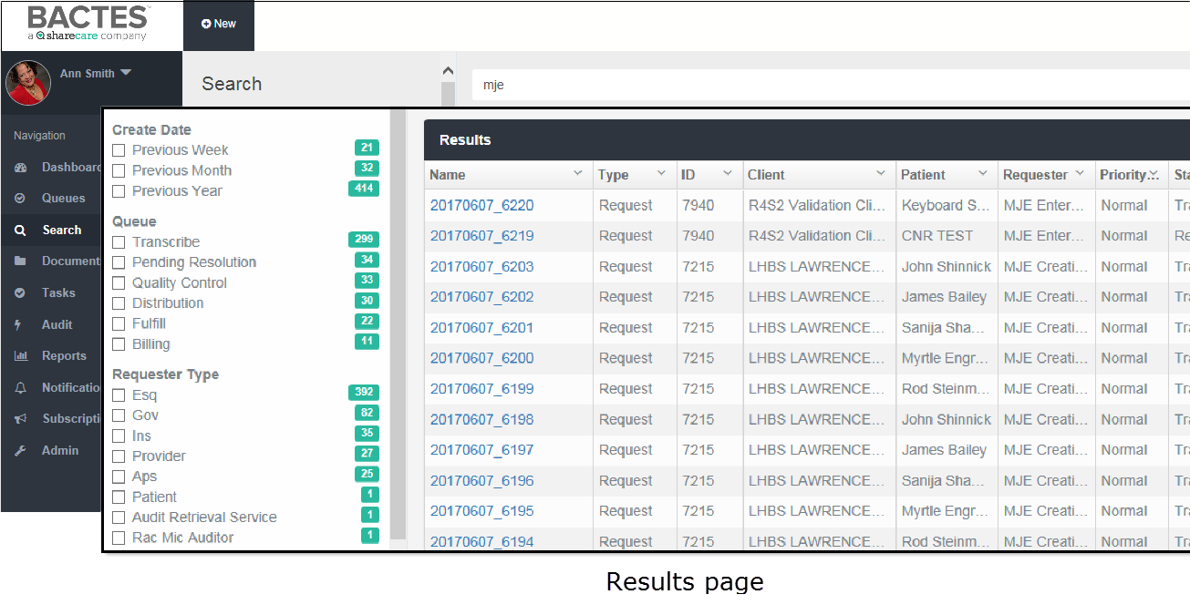

The results organize in the following columns.

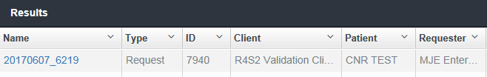

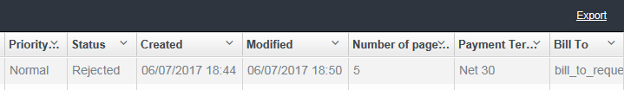

Not all search results return these identifiers.

### Filter the list

Along with the search results, a set of corresponding ***facets*** displays in the ***Browse*** frame.

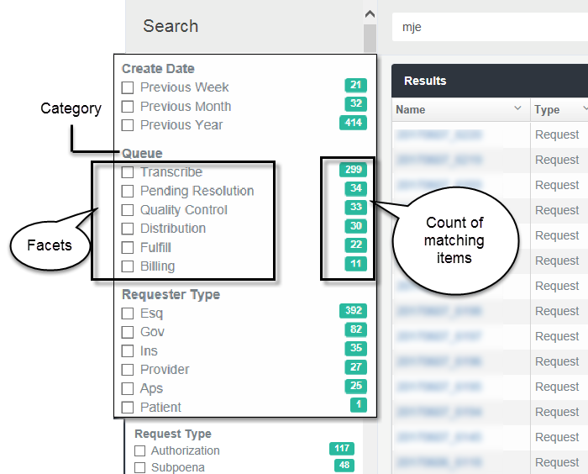

Facets are like filters. Use one or more facets to narrow the number of results that display. The facets you see vary by the search results and by the previous filter. Each facet shows the number of results that correspond to that filter.

* + Select or clear the facet check box(s) to create a filter.

The list of results will adjust as facets are added or removed.

### Find specific results

When a set of multiple results returns, you can conduct a *search* of the *search results*.

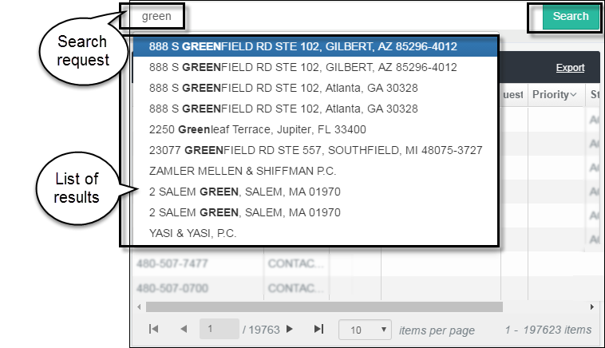

* In the text box above the results, type criteria for the search.

As you type, the system may *predict* your search in a list of matching results.

* + If the predictive list contains the specific result you want, select the item from the drop-down list.
  + If you want a broader group of results, click **Search**.

The set of results will adjust to the list option you choose.

### Re-order the list

You can change the sequence in which the results list in the space. The options are available in each column of data.

* 1. To sort the list of results, click the  **Disclosure** (down arrow) button in a column heading.

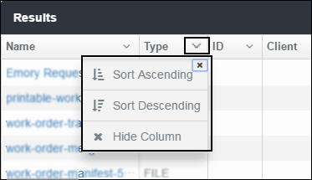

* 1. Sort the list in **Ascending** order (A-Z, 1-x) or **Descending** order (Z-A, x-1) of the selected column.

### Hide a list column

* 1. To hide a column from display, click the  **Disclosure** (down arrow) button in a column heading.



* 1. Click **Hide Column** toremove it from view.

### Adjust column width

You can widen (or narrow) the size of any column in the results list.

1. In the header row at the top of the list, place the cursor on the column border. The cursor will change to a double arrow.

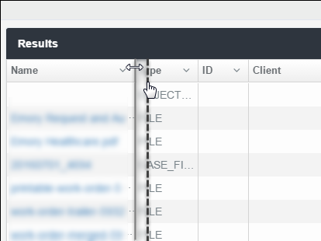

1. Drag the line to the right or left to adjust the width.

### Adjust the list size

The default number of list items on each search results page is **10**. If your preference is to scroll a list rather than move between pages, you can increase the number of list items that appear on the screen. Likewise, you can show fewer items on each page.

1. To increase (or decrease) the number of results you want to see on each screen (page), scroll to the bottom of the results list.

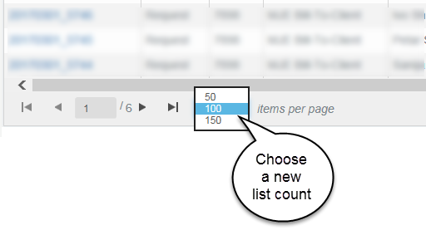

The default display setting for the results list is 100 items per page. You can change the count to **50** or **150**.

1. Click to select a new count. The selection drop-down closes and the list length adjusts to the new size.

The change to the list count is active only for the current session. The count resets to the default when you leave the Search screen.

### Navigate the list pages

To move between pages of results, use to ***GoTo*** arrows at the bottom of the list.

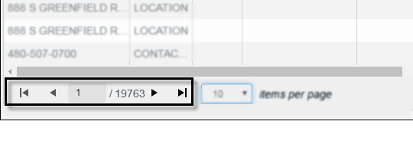

1. Right arrows move forward: Click ▶ to open the **next page**, or ▶| to go to the **last page** of the list.
2. Left arrows move backward: Click **◀** to open the **previous page**, or **|◀**  or to return to the **first page** of the list.

### Export results

You can export the search results list to a Microsoft Excel spreadsheet. Once in a spreadsheet, you can use all the Excel tools to manipulate the content.

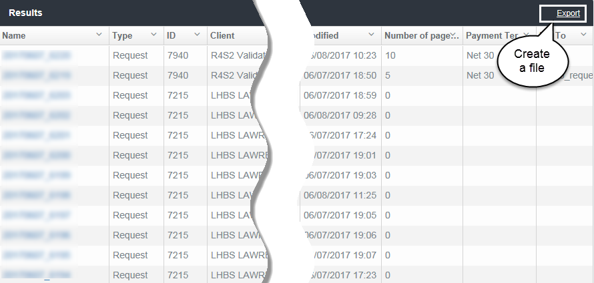

1. When you have created the set of results you want, click **Export**.

HDS exports the results to a comma separated values (CSV) file.

**File name**

The system assigns a generic name to the file, for example, *undefined* and the date.



1. When the prompt appears at the bottom of the screen, choose an option.
   * Open the file
   * Save – Save and location, Save As and location, Save and open.

## Queue Search

You can use the text fields in the Queue column headings to filter content or locate specific content. The rules for filtering and searching vary slightly by column.

### Request column

Enter one or more numbers in the column search box.

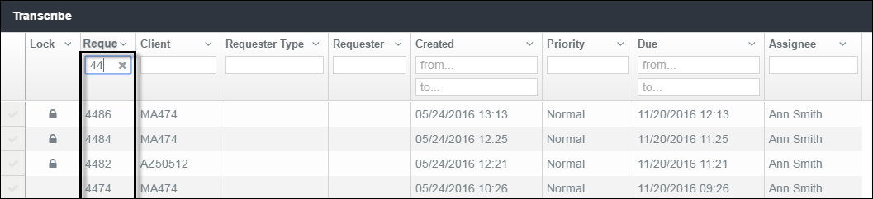

Filters a group of requests or locates a specific request.

### Client column

This column requires entry of the complete client identifier.

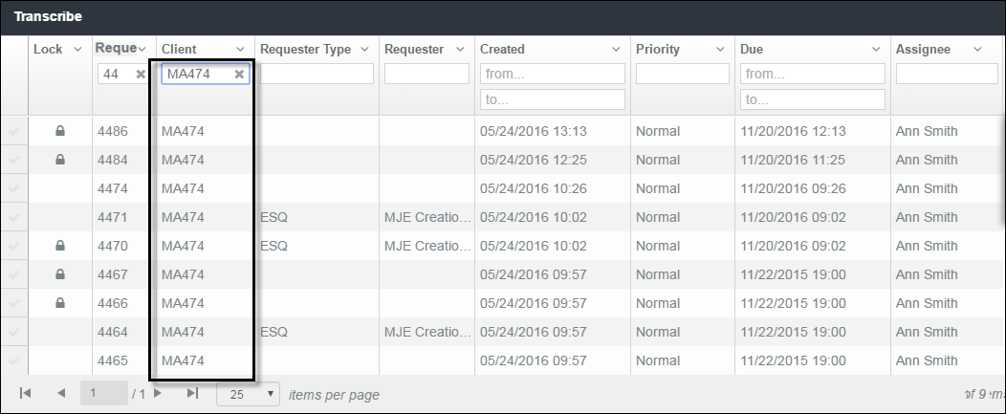

### Requester columns

Partial entry is acceptable to retrieve requester information.

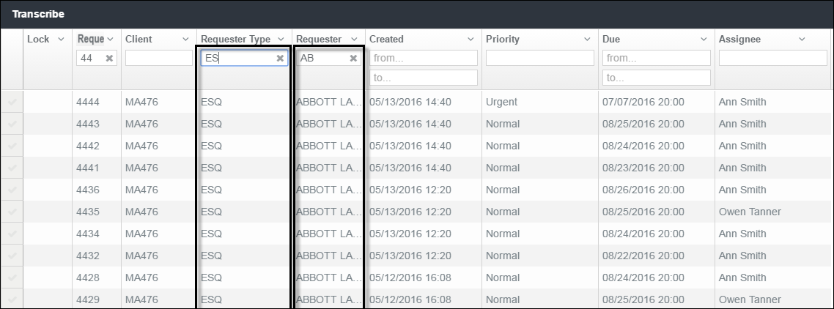

### Date columns

Type in the full dates.

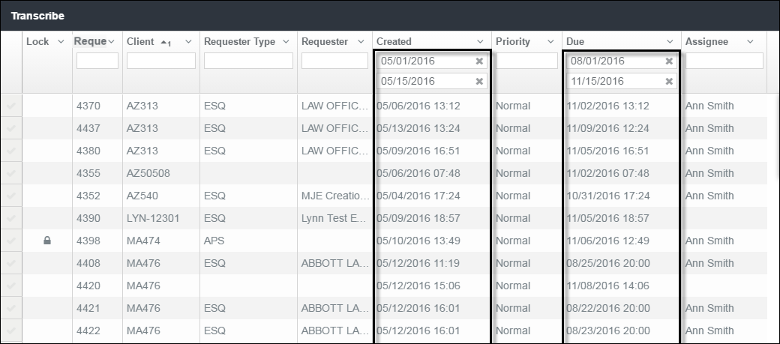

Filtering by date requires full entry of either or both ***Created*** and ***Due*** dates. Date range requires at least a one-day time span.

### Priority column

Filter the list of requests by priority.

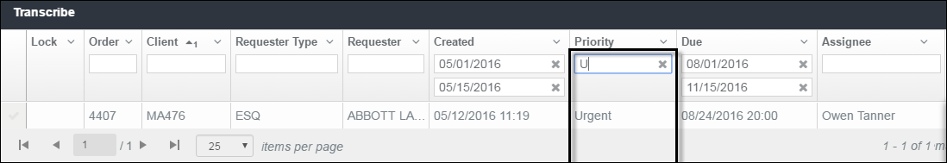

### Assignee column

View requests by assignment.

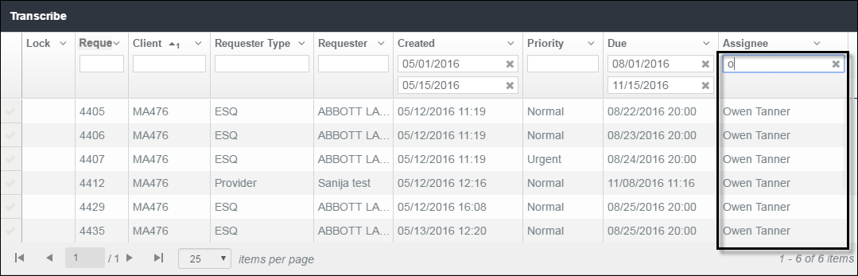

Begin typing a name to filter by assignee. Field is not case-sensitive.

# Reports

HDS currently makes available the ***Turnaround Time by Requester*** report.  Not all people have permission to run the report of clients.

Topics in this chapters

**Define a report**

Steps for creating a set of results.

**View report results**

Options for organizing and navigating the report.

**Create a copy of the report**

Steps for saving the report as a separate file.

## The Reports Page

The **Reports** module lets you choose the clients and date range for a report.

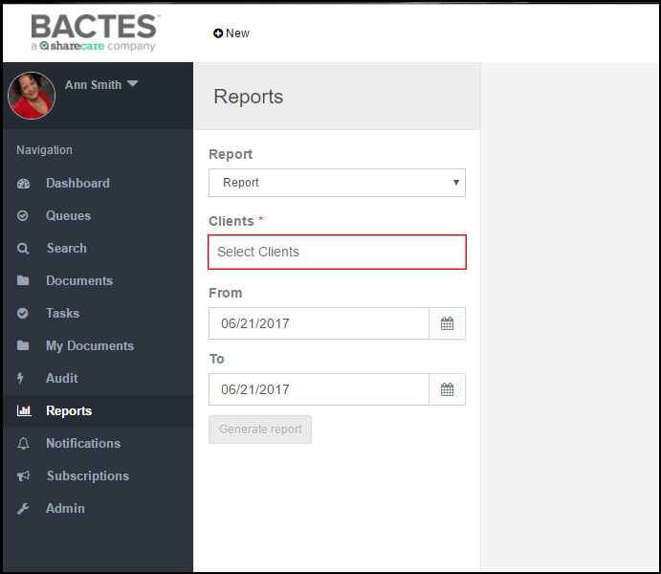

Search criteria are created in the ***Browse*** frame. The ***Generate report*** button is enabled only when required fields are complete.

## Define a Report

The report request criteria allow you to tailor results, and conserve search time and the amount of physical data returned. All fields are required. That includes the ***Report*** (name) field.

1. In the **Report** field, select **Turnaround Time by Requester** report so it appears in the field.

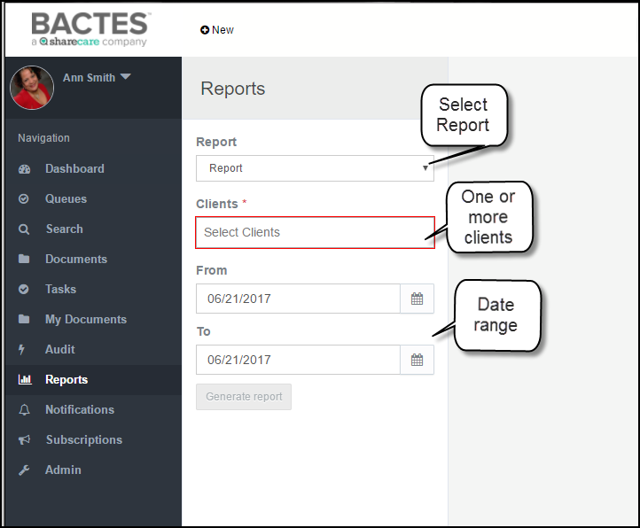

1. Click in the Report field and select **Request Status** or **Turnaround Time by Requester.**

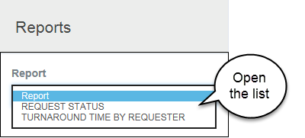

Even though the Report field does not indicate *required* (**red** outline or asterisk), the report name must be selected and appear in the field.

1. Click in the **Clients** field and start typing a name or client number. It’s a *predictive* entry field so the system collects a list of potential matches. When the correct option appears in the list, click it to move the name into the field.

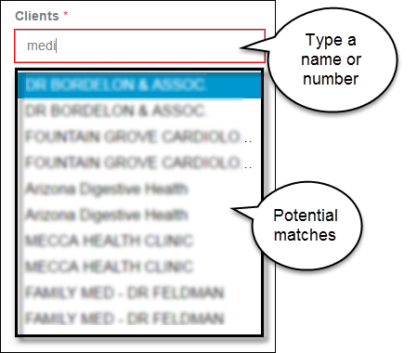

1. To report on more than one client, start typing the next name or number and select it when it appears on the drop-down list of potential matches.
2. Use the **Date Range** fields to confine the results to a period. (The default is today; leaving it as-is returns one day’s results.)

* In the *From* and *To* boxes, enter, or select from the calendar, a date range.

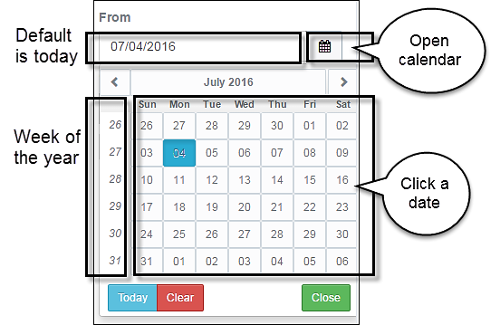

* If manually entering, follow in the same format as shown in the field: MM/DD/YYYY.
* To select the date for either or both fields, click the date picker icon to open the calendar.

The buttons in the month title panel open the previous **|<|** month or the next **|>|**month.

1. Click **Generate Report** to return the results.

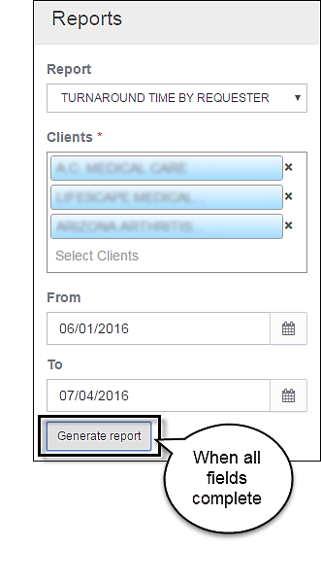

The report displays in the ***Detail*** frame of the page.

## View Report Results

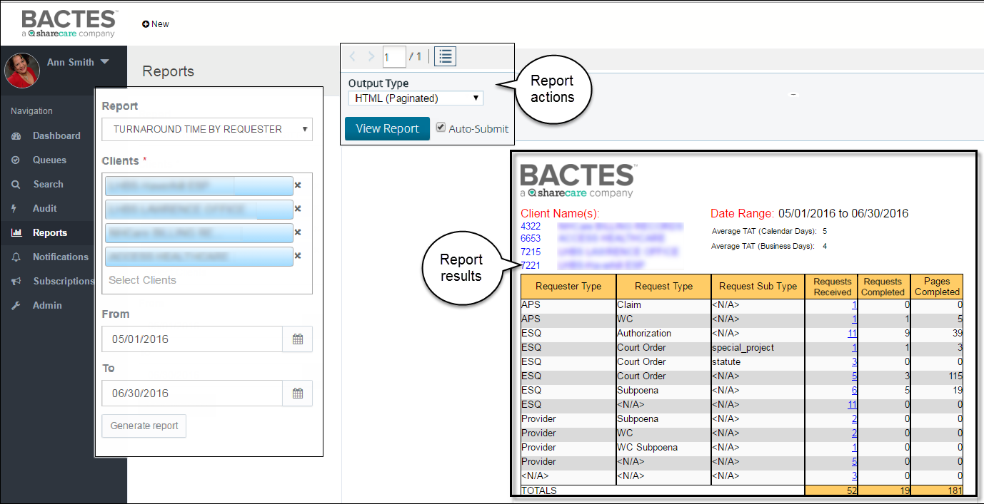

**Report Actions**

By default, the new report page makes available options for formatting and viewing the content. The group of options appears in the *View Report* panel above the report results in the upper-left corner of the ***Detail*** frame.

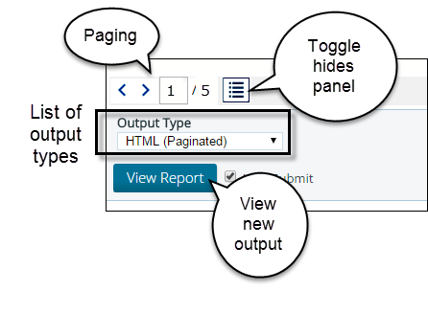

* **Left and right arrows**: click **|>|** arrow-right to move ahead one page in the results, click **|<|** arrow-left to go to the previous page.
* **Number of pages** in the report: shows the *page of pages*, for example 1 / 5, where you can enter a number in the box and jump to any page of the report.
* **Toggle button** expands the space for viewing the report. It hides (and redisplays) the *View Report* panel that appears above the report content.
* **Output Type dropdown** is a list of options for saving the report. Use the ***View Report*** button to see the report in the new file format.

**Report Results**

The report results show up to 20 list items on a display page.

### Request Status Report

The Request Status Report will closely resemble the example below.

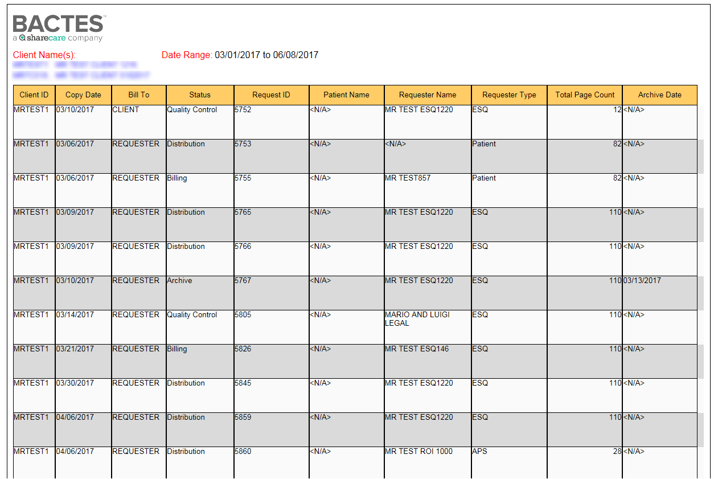

### Turnaround Time by Requester

The Turnaround Time by Requester Report will closely resemble the example below.

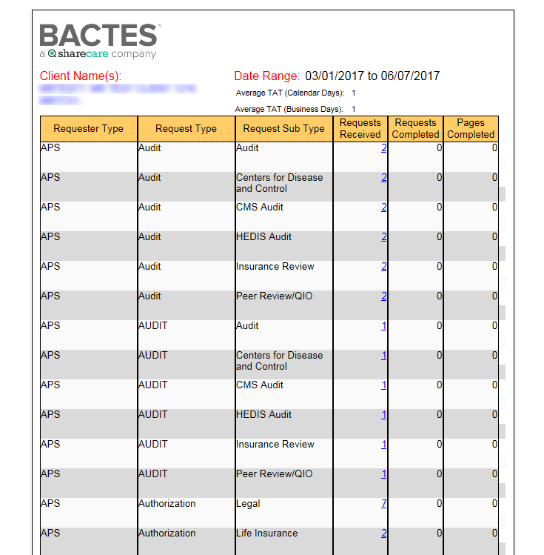

**Report Web Viewer**

A link in the ***Requests Received*** column of the **Turnaround Time by Requester** Report opens a status summary of each request received. The example below shows the content of the summary.





The example identifies one request that has been completed and is in archive.

## Save the Report

The onscreen report results is a fixed display. It is an orderly presentation of the records collected from the database. As is, its content cannot be manipulated, copied, or printed from the page.

To create a copy of the report, save it in another format.

1. Click in the Output Type field to open the list of available file types.

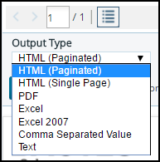

1. Click to select a file type. If the new file does not open, click **View Report**.
2. Save or view in the selected file format.

**Output Type**

The ***Output Type*** box is a list of options for making the content available for other purposes. The default display is HTML, in paginated form.

|  |  |
| --- | --- |
| *Formats* | *Results* |
| **HTML (Single Page)** | Shows the onscreen results in a single-page, scrollable format. |
| **PDF** | Opens the results as a .pdf file, which you can save. |
| **Excel** | Creates a spreadsheet of the report, in which the content can be used like any other Excel file. |
| **Comma Separated Value** (CSV) | Formats the report in a spreadsheet, suitable for copying to a database or another environment. |
| **Text** | Creates a plain text file for use in generic text editors and utilities. |

# Audit

Authorized users can view all HDS system activity (events) associated with requests and files. The **Audit** module provides the capability for defining the audit and the options for saving the results.

Topics in this chapter

**Define an audit**

Steps for creating a set of results.

**View audit results**

Options for organizing and navigating the audit.

**Create a copy of the audit**

Steps for saving the audit as a separate file.

## The Audit Page

The **Audit** module makes available a set of parameters for specifying the content of an audit. Define the audit completing the fields in the *Browse* frame.

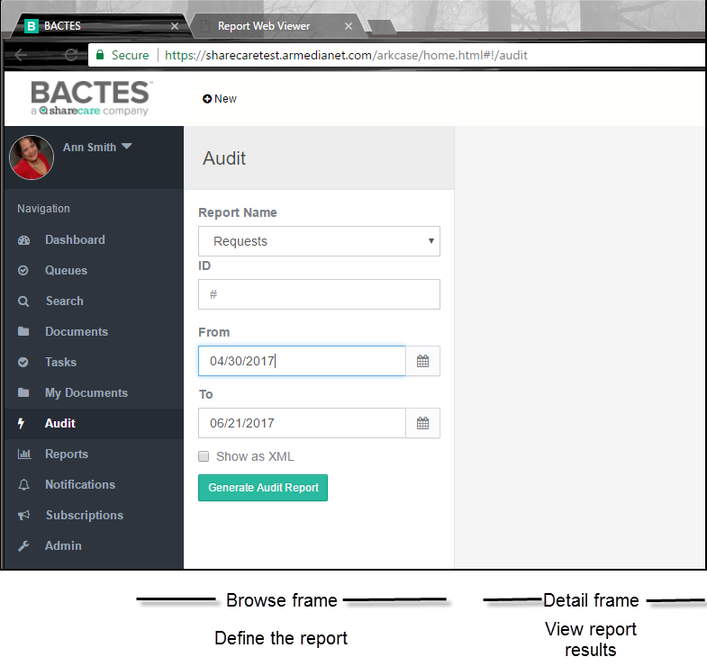

Audit content can be based on type of information (*Object Type*), such as requests or files, or on ***All***.

**A note about *All* audit reporting**

It is wise to use ***All*** with discretion, particularly with a blank ***ID*** field or for a wide time span. Audit results are comprehensive, including business-level activity as well as records of behind-the-scenes system events. As the repository grows, the required time and amount of results of too-broad criteria may have minimal advantage.

An entry in the **ID** field will audit a specific request: actions on the request or one of its files. You can define a date range for the audit—activity today or for a wider time span.

## Define the Audit

Select the audit criteria in the ***Browse*** frame. The criteria tailor results, and conserve search time and the amount of the physical data returned.

1. To open the module, click the **Audit** tab in the Navigation frame.

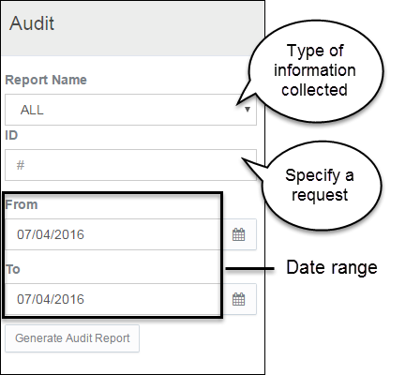

1. In the **Report Name** field, select the type of information to audit.

* Requests
* Files
* All (default)

For example, to audit all activity for today, leave the default *All.* Add a request number tosee all associated request-level and file-level activity.

1. Complete the **ID** field to audit one specific request.
2. Use the **Date Range** fields to confine the results to a period. (The default is today; leaving it as-is returns one day’s results.)

* In the *From* and *To* boxes, enter, or select from the calendar, a date range.
* If manually entering dates, follow in the same format as shown in the field: MM/DD/YYYY.
* To select the date for either or both fields, click the *date picker* icon to open the calendar.

The buttons in the month title panel open the previous **|<|** month or the next **|>|**month.

1. Click **Generate Audit Report** to return the audit results.

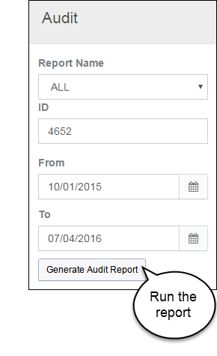

The report displays in the ***Detail*** frame of the page.

## View Audit Results

The report displays up to 20 entries on a page. Audit results list by date, descending order (newest first).

***Request-level Audit***

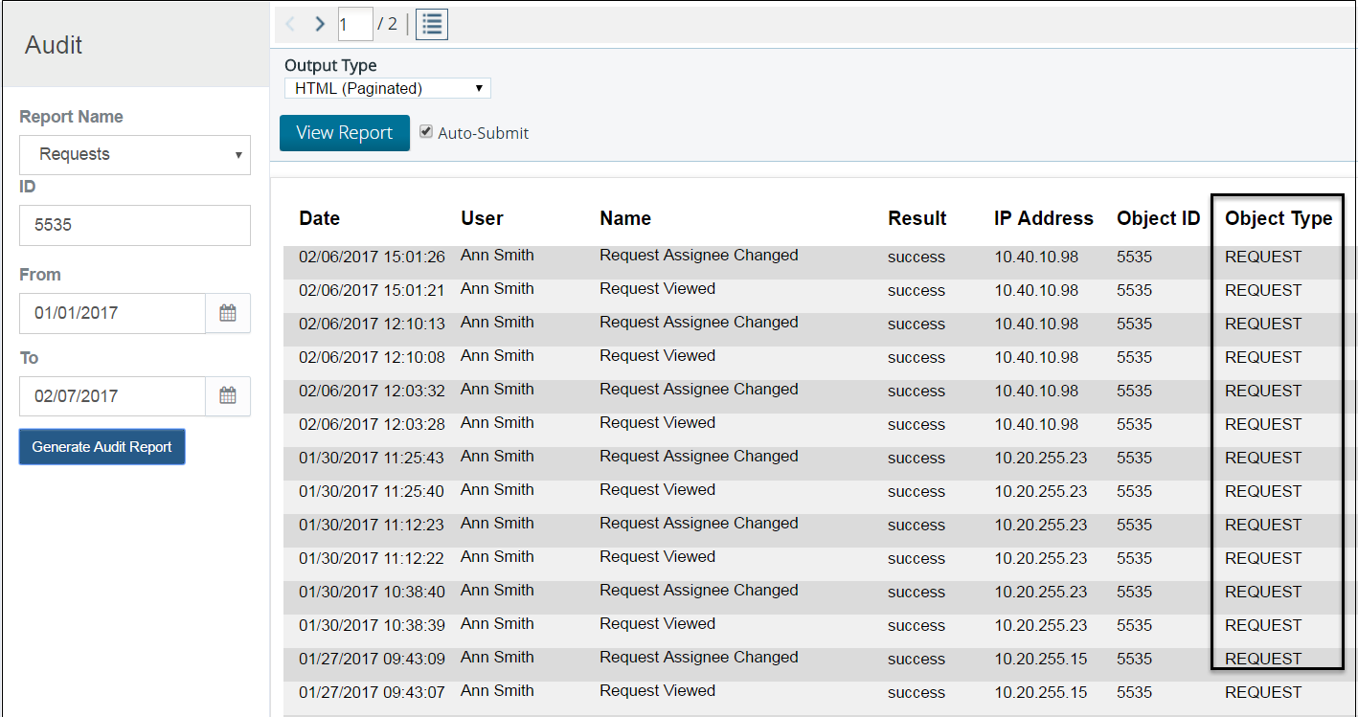

***File-level Audit***

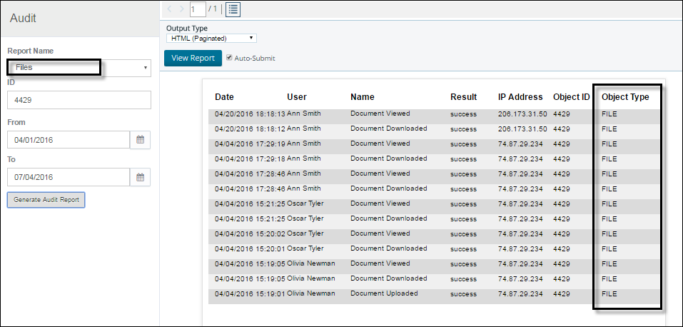

***“All” Audit***

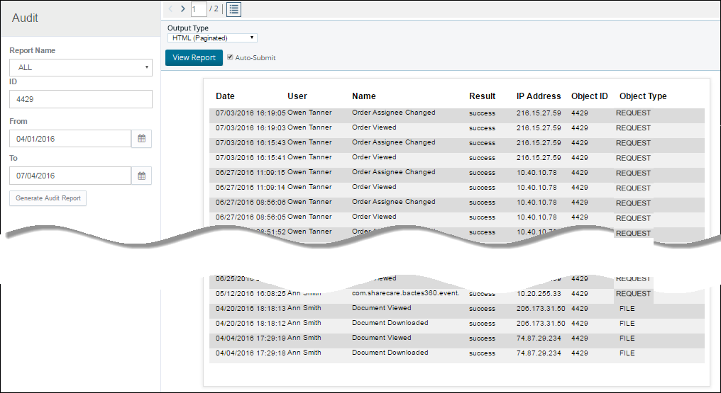

**Audit Report Content**

| *Report column* |  |
| --- | --- |
| **Date** | The date and time that the action occurred. |
| **User** | The person who initiated the action. |
| **Name** | The action that occurred, for example, the item was viewed, changed, or downloaded. |
| **Result** | The requested action successfully occurred or it did not. |
| **IP Address** | The computer from which the action was taken. |
| **Object ID** | The associated request number. |
| **Object Type** | Either *Request* , *File or All* . If you opt for ALL, Object Type can be Request, Task, File, Widget_List, etc. |

**Report Actions**

By default, the audit results page makes available options for formatting and viewing the content. The group of actions appears in the *View Report* panel above the results in the upper-left corner of the ***Detail*** frame.

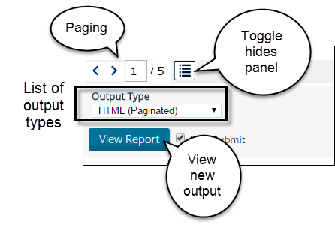

* **Left and right arrows**: click **|>|** arrow-right to move ahead one page in the results, click **|<|** arrow-left to go to the previous page.
* **Number of pages** in the report: shows the *page of pages*, for example 1 / 5, where you can enter a number in the box and jump to any page of the report.
* **Toggle button** expands the space for viewing the report. It hides (and redisplays) the View Report panel that appears above the report content.
* **Output Type dropdown** is a list of options for saving the report. Use the ***View Report*** button to see the report in the new file format.

## Save the Audit Report

The report results is a fixed display of data that has been collected from the database. As is, its content cannot be manipulated, copied, or printed from the on-screen page.

To create a copy of the report, save it in another format.

1. Click in the *Output Type* field to open the list of available file types.

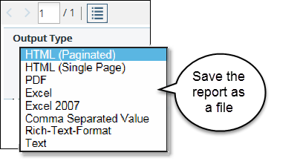

1. Click to select a file type. If the new file does not open, click **View Report**.
2. Save or view in the selected file format.

**Output Type**

The ***Output Type*** box is list of options for making the content available for other purposes. The default display is HTML, in paginated form.

|  |  |
| --- | --- |
| *Formats* | *Results* |
| **HTML (Single Page)** | Shows the onscreen results in a single-page, scrollable format. |
| **PDF** | Opens the results as a .pdf file, which you can save. |
| **Excel** | Creates a spreadsheet of the report, in which the content can be used like any other Excel file |
| **Comma Separated Value** (CSV) | Formats the report in a spreadsheet, suitable for copying to a database or another environment. |
| **Rich-Text Format** | Creates a Microsoft Office-compatible (Word) version of the report. |
| **Text** | Creates a plain text file for use in generic text editors and utilities. |

# 

# Administration

Authorized users configure application settings in the **Administration** module. The module is the central location for customizing and maintaining HDS for ongoing business use.

HDS streamlines administration—not all business-level modifications require technical intervention. Authorized users can easily make changes *on the fly* (effective immediately).

The **Administration** module is structured for object-based management control. A visually oriented user interface simplifies the capabilities for managing security, setting access permissions, integrating business process, and conforming business context.

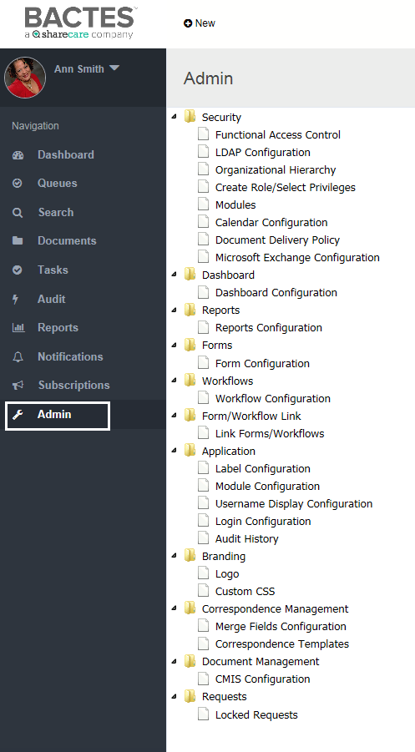

The Admin browse frame lists the application objects that can be configured. Select an object from the tree-view list to open its configuration detail.

## Security

Use to configure functional access—associate LDAP and ad hoc groups to each application role. The Lightweight Directory Access Protocol (LDAP) is the group structure used at the organization level (HDS enterprise). HDS access control defers to the LDAP settings. Authorized users can view the LDAP group structure and create and manage ad hoc groups.

**Functional Access Control**

**LDAP Configuration**

**Organizational Hierarchy**

**Create Role/ Select Privileges**

**Modules**

### Functional Access Control

Purpose: authorize application roles.

1. In the Security folder, click **Functional Access Control**. The existing application roles appear in the *Choose Application Role* list.

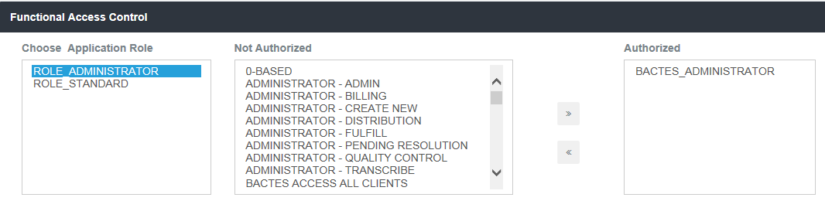

Use the selections to create functional access assignments.

1. To enable controls, click a group name from the ***Not Authorized*** list and click the  right chevrons button to move it to the ***Authorized*** list.
2. To remove authorization, click the group name from the ***Authorized*** list and click the  left chevrons to move it to the ***Not Authorized*** list.

### LDAP Configuration

Purpose: create and maintain LDAP directories integrated in HDS.

The LDAP directory(s), on which HDS group and individual permissions are based, are listed on the page. (See example below.)

#### Modify an LDAP Configuration

1. In the Security folder, click **LDAP Configuration**.

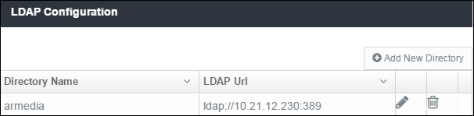

1. To modify an existing directory, such as the directory name, LDAP URL and other attributes, click the  edit button. The ***Edit Record*** window shows the existing attributes in text fields.

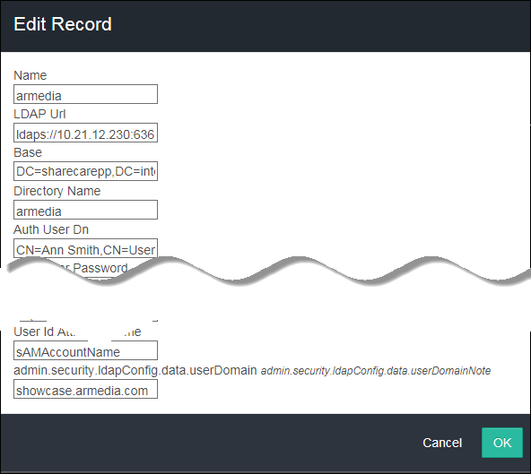

1. To save updates, click **OK**.

#### Add New LDAP Directory

1. Click the **Add New Directory** button at top-right on the page. A blank record opens, like the example below.

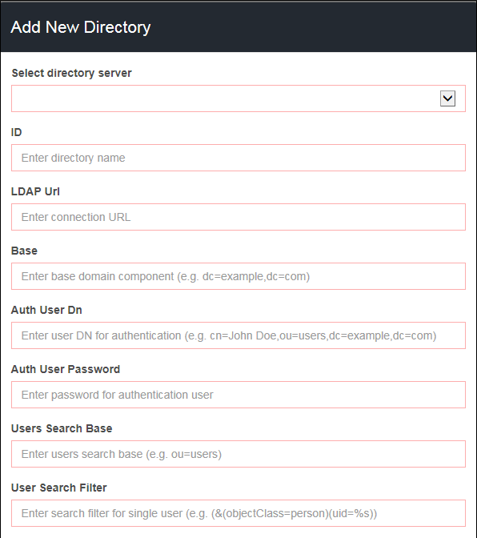

Required fields are marked in **red**. Click **OK** to add the directory to the LDAP configuration list. The button is dimmed (not available) until you enter the minimal information.

### Organizational Hierarchy

Purpose:

* Store and maintain all HDS-LDAP groups (queue and admin access)
* Create and manage all HDS ad hoc groups (client access)

In the Security folder, click **Organizational Hierarchy**. The current organizational hierarchy shows the structure for the LDAP and ad hoc groups.

#### Ad hoc groups

A collection of ad hoc groups appears in the hierarchy list. Actions are available specifically for ad hoc groups.

##### Managing members

***View group members***: expand the folder to see the current group membership.

***Remove a group member***: click the delete icon to remove a member from the group.

##### Managing groups

Use the set of icons for group-level actions (hover on an icon to view its function).

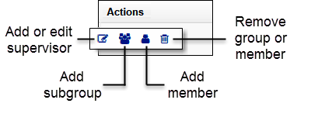

***Add people***: when adding people, the dialog box opens to search for names.

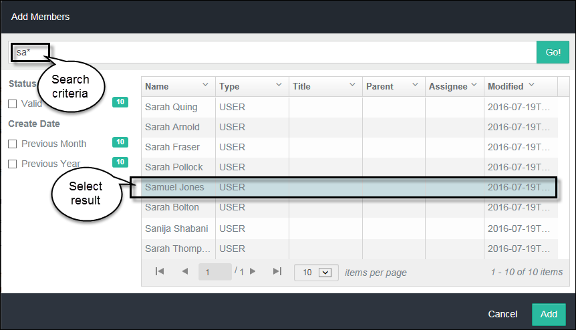

1. Type full or partial name and click **Enter** or **Go!**. The ***Add*** button becomes available only after the results appear.
2. Select the name from the results and click **Add**.

***Add groups***: a text dialog box opens to create a new ad hoc group or subgroup.

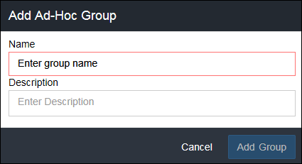

Group name is minimum required information (text box outlined in red). The ***Add Group*** button becomes available only after entering text in the ***Name*** field.

**Note**: The system automatically creates an ad hoc group when it receives a new client from CRM.

***Remove a group***: click the delete icon.

#### LDAP groups

A collection of LDAP groups appears in the hierarchy list. You can only view the membership lists of the HDS LDAP groups.

***View group members***: expand the folder to see the current group membership.

### Create Role/ Select Privileges

Purpose:

* Assign privileges to user roles
* Create roles and edit role titles

1. In the Security folder, click **Create Role/ Select Privileges**.

***Note***: The options you see may be different than this example.

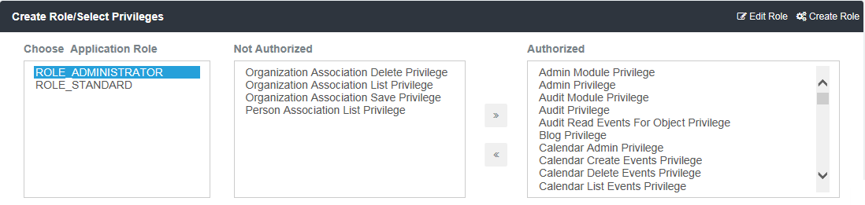

1. Select an ***Application Role*** from the first list.
2. Use the chevron buttons to move privileges between the ***Not Authorized*** and ***Authorized*** lists.
   1. Click the  right chevrons button to move a privilege to the ***Authorized*** list.
   2. Click the  left chevrons to move a privilege to the ***Not Authorized*** list.

#### Edit Role

The current role name appears in the text box.

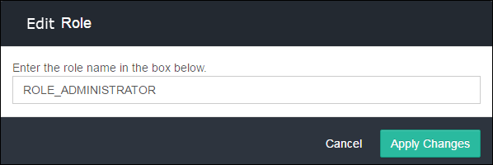

Type in the revision to the name and click **Apply Changes**.

#### Create Role

Use the space for creating new roles. Enter the name in the text box.

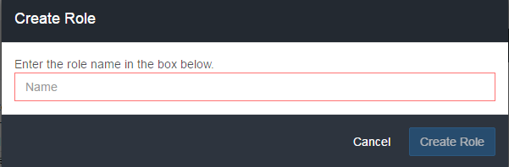

The field is required (framed in red). Click **Create Role** when the button becomes available. The new role appears in the ***Application Role*** list.

### Modules

Purpose: Set role permissions for access to each HDS module.

1. In the Security folder, click **Modules**.

***Note***: The list of modules you see may be different than this example.

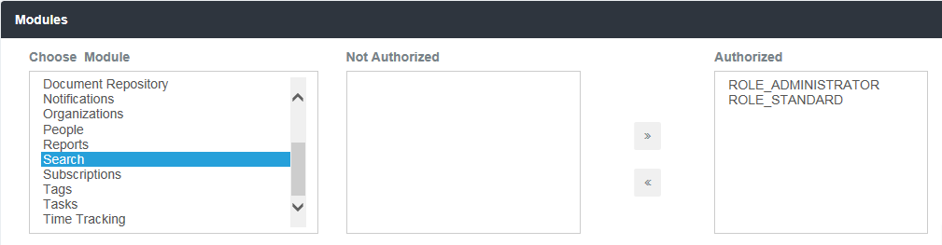

1. Select a module from the ***Choose Module*** list.
2. Use the chevron buttons to move individual roles between the ***Not Authorized*** and ***Authorized*** lists .
   1. Click the  right chevrons button to move a role to the ***Authorized*** list.
   2. Click the  left chevrons to move a role to the ***Not Authorized*** list.

## Dashboard Configuration

Purpose: Use to assign access authorization to module objects.

1. In the ***Admin*** explorer frame, open the ***Dashboard*** folder and click **Dashboard Configuration**.

**Note**: The configuration screen you see may be different than this example.

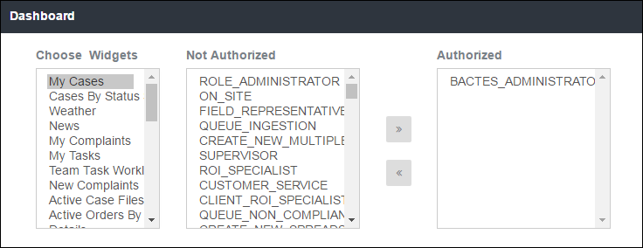

1. Click a widget from the ***Choose Widgets*** list.
2. Use the chevron buttons to move individual roles between the ***Not Authorized*** and ***Authorized*** lists.
3. Click the  right chevrons button to move a role to the ***Authorized*** list.
4. Click the  left chevrons to move a role to the ***Not Authorized*** list.

## Reports Configuration

Purpose: Authorize access to Reports.

1. In the ***Admin*** explorer frame, open the ***Reports*** folder and click **Reports Configuration**.

**Note**: The configuration screen you see may be different than this example.

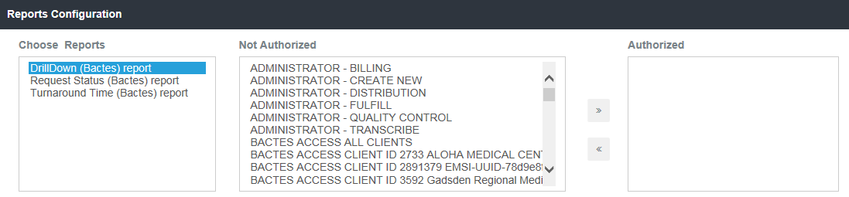

The report name will be highlighted.

1. Use the chevron buttons to move individual roles between the Not Authorized and Authorized lists.
   1. Click the  right chevrons button to move a role to the ***Authorized*** list.
   2. Click the left chevrons to move a role to the ***Not Authorized*** list.

## Workflow Configuration

Purpose: Use to manage Queue process workflows. The page shows a list of existing workflows.

* In the ***Admin*** explorer frame, click **Workflow Configuration**.

**Note**: Not all of the workflows in the example may be relevant to the current HDS environment.

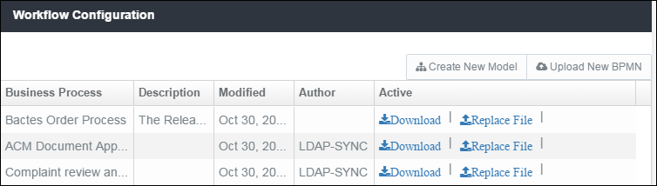

|  |  |
| --- | --- |
| *Workflow status* |  |
| **Business Process** | Name of the workflow |
| **Description** | If included, describes the workflow. |
| **Modified** | The date of the most current version. |
| **Active** | **Download** a new workflow file for review.  **Replace File** and create a new version.  **Version History** of the workflow, provides the option to reinstate a previous version. |
| **Create New Model** | N/A |
| **Upload New BPMN** | Add a new Business Process Model and Notation (new workflow). |

## Application Configurations

### Label Configuration

Purpose: Use Label Configuration to customize the user interface.

* In the ***Admin*** explorer frame, open the ***Application*** folder and click **Label Configuration**.

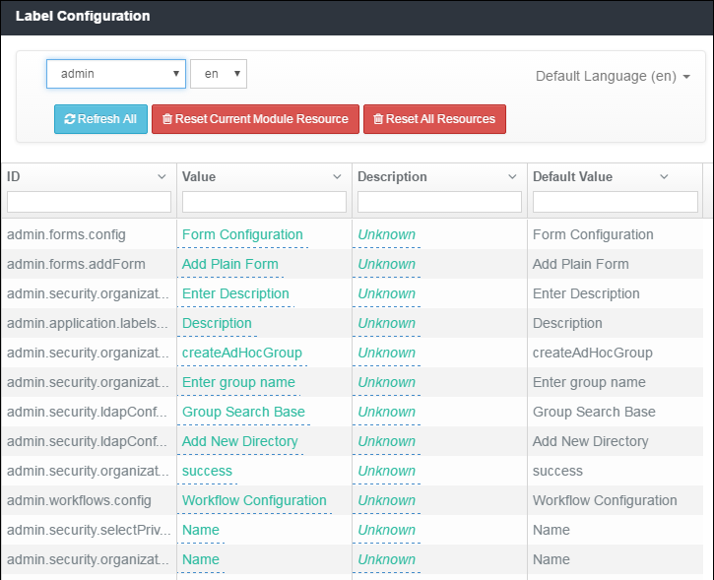

Each module (HDS modules and integrated application modules) has a list of pre-defined labels. Labels are associated to fields, messages, buttons, table titles, table columns, form names, and more.

|  |  |
| --- | --- |
| **Module list box** | Click in the top-left field (default is ***admin***) to view the list of modules.  Select a module from the list, for example, Audit, Reports, and Queues, or request-info, document-details, and upload-new-request to see its labeled objects. |
| **Language** | Pre-set to *en* (English-U.S.). |
| **ID** | System-defined object. These are not modified.  To filter the list or find a specific ID, type a partial or full ID name in the column heading text field. |
| **Value** | The title (label) for the object. You can customize the values for any of the labels. The initial value matches the system default value listed in the ***Default Value*** column.  To filter the list or find a specific value, type a partial or full name entry in the column heading text field. |
| **Description** | You can add a description for each label.  To filter the list or find a specific value, type a partial or full name entry in the column heading text field. |
| **Default Value** | System-defined value, does not change.  To filter the list or find a specific value, type a partial or full name entry in the column heading text field. |

|  |  |
| --- | --- |
| **Column list** | Click the disclosure button in a column heading to reorder or hide the list   * **Ascending order** * **Descending order** * **Hide column** |

#### Changing labels

1. To change a Value or Description, click the current value to open a pop-up box.

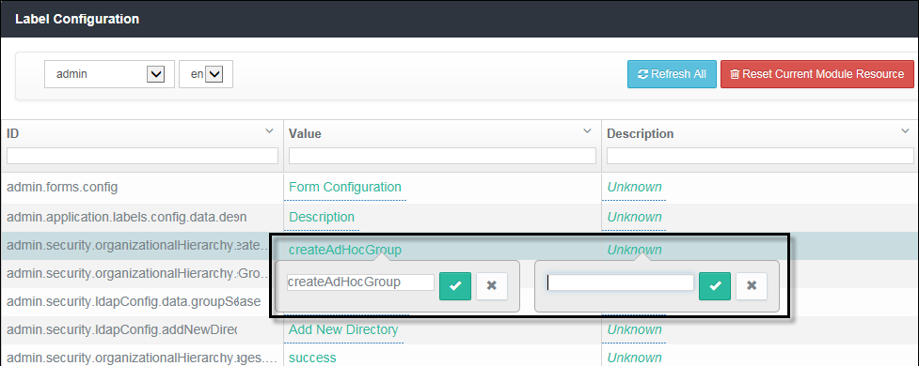

1. Type in the new value.
2. Click the check mark to save the change and close the pop-up box.

Click the **X** button to cancel the change and close the box.

### Module Configuration

Purpose: Use Module Configuration to enable the objects within the modules.

1. In the ***Admin*** explorer frame, open the ***Application*** folder and click **Module Configuration**.

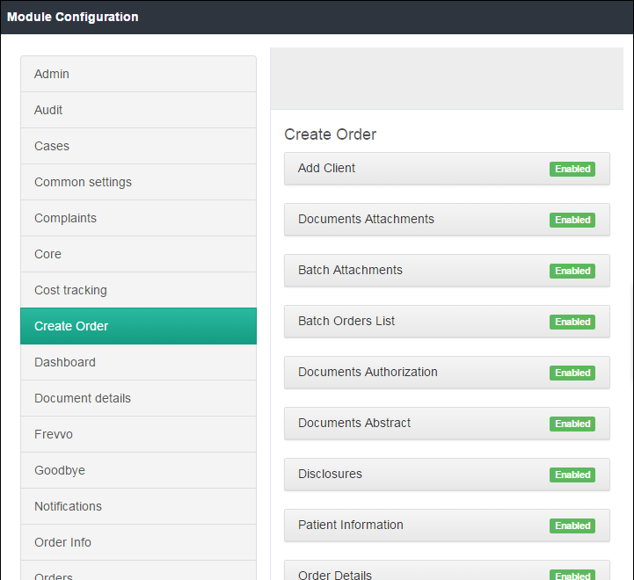

The page shows the list of modules in the left frame.

1. Click a module to see its configurable objects.
2. To change the status of an object, click the button to toggle between **Enabled** and **Disabled**.

## Branding

Purpose: Maintain global elements that customize the site.

* In the ***Admin*** explorer frame, open the ***Branding*** folder and click **Logo** or **Custom CSS**.

### Logo

Purpose: Store the logo(s) that will display in HDS.

The logos will appear in the Header title and the Login title.

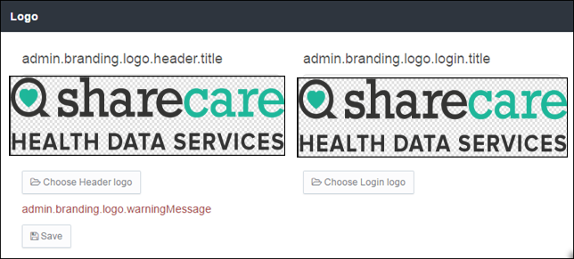

1. Click **Choose** to add or replace a logo.
2. Click **Save** to update the logo.

### Custom CSS

Purpose: Maintain the colors that appear on the pages.

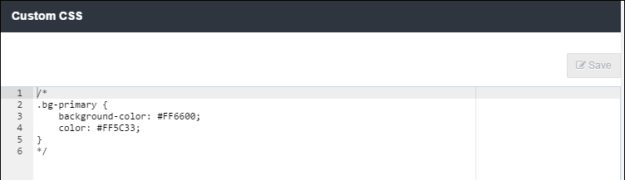

* To modify, change the CSS code and Save.

## Correspondence Templates

**----Future Release----**

Purpose: Add and maintain the collection of correspondence templates.

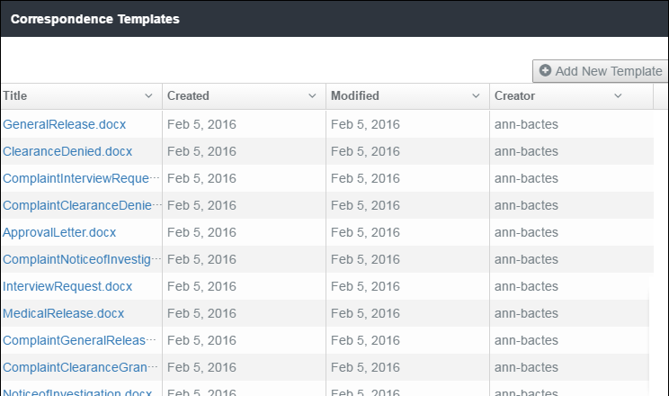

**Modifying a template**

To modify an existing template, click the file name in the ***Title*** column. The **Do you want to save or open** dialog box opens at the bottom of the screen. Select open or a save option to proceed.

With the template (document) opens, make changes and save the file. If you did not save the file before editing, Windows Explorer opens. Choose the save location.

**Replacing a template**

Click **+ Add New Template** on the ***Correspondence Templates*** title bar to open Windows Explorer. Browse your folders and select the document, then click **Open**. The document (of the same name) replaces the previous version.

**Adding a template**

Click **+ Add New Template** on the ***Correspondence Templates***title bar. Windows Explorer opens.

Browse and select the document from your share drive.

Click **Open**.

## Locked Requests

Purpose: Administrators can unlock requests.

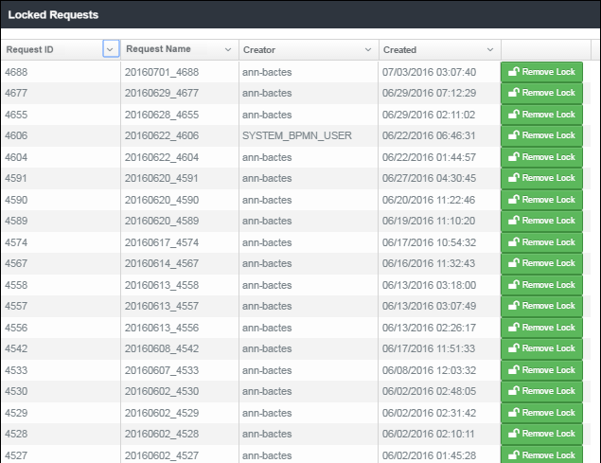

All locked requests appear on the list. The **Remove Lock** button changes the lock status.